
GUIDING HARBOR
2017
Supervised Independent Living and the Young Adult Voluntary Foster Care
Handbook


TABLE OF CONTENTS

TOPIC PAGE

SIL FORMS……………………………………………………………………………………. 3
EMERGENCY TELEPHONE NUMBERS………………………………………………….. 4
MISSION STATEMENT AND VISION……………………………………………………… 5

PROGRAM STATEMENT…………………………………………………………………….. 6

WELCOME …………………………………………………………………………………….. 7

HOME PROVIDERS……………………………………………………………………………. 9
PERMANENCY PLANNING GOALS ……………………………………………………… 9
WHERE WILL I LIVE?………………………………………………………….………….…. 10
WHO WILL ASSIST ME?………………………………………………………………………. 10
WHAT SERVICES WILL I RECEIVE?……………………………………………….……… 11
SIL/YAVFC…………………………………………………………………………….. 11
CLINICAL INTERVENTION …………………………………………………………. 12
INDIVIDUALIZED ADVOCACY SERVICES ………………………………………. 12
INDIVIDUAL CASE PLANNING …………………………………………………….. 12
EMPLOYMENT ASSISTANCE ……………………………………………………… 13
FINANCIAL PLANNING & ASSISTANCE…………………………………………… 13
EDUCATIONAL PLANNING & ASSISTANCE ……………………………………. 13
MEDICAL & DENTAL CARE …………………………………………………………. 14
MENTAL HEALTH……………………………………………………………………… 14
PSYCHOTROPIC MEDICATION…………………………………………………….. 16
FAMILY REUNIFICATION SERVICES ……………………………………………… 21
CRISIS INTERVENTION ……………………………………………………………… 21
PORTFOLIO ……………………………………………………………………………. 22
SIL/YAVFC CONTRACT………………………………………………………………. 22
WHAT ARE MY RIGHTS?………………………………………………………….…………. 23
RELIGIOUS EXPRESSION…………………………………………………………… 23
MAIL ……………………………………………………………………………………. 23
DISCIPLINE ……………………………………………………………………………. 23
ADDITIONAL INDEPENDENT LIVING SERVICES……………………………………… 23
FAMILY TEAM MEETINGS …………………………………………………………….. 26
CLIENT’S RIGHTS…………………………………………………………………………… 28
GRIEVANCES & COMPLAINTS ……………………………………………………………. 30
THE GRIEVANCE PROCEDURE…………………………………………………….……. 30
PRIVACY & CONFIDENTIALITY…………………………………………………….…….. 31
INDEPENDENT LIVING RECORD………………………………………………………… 31
PROGRAM EXPECTATIONS………………………………………………………………. 32

INDEPENDENT LIVING MODULES……………………….………………………………. 32
VISITORS………………………………………………………………………………….… 33
RUNAWAY/AWOL...………………………………………………………………………….. 33
AWOL PROCEDURE………………………………………………………………………… 34
OUTINGS & CURFEWS……………………………………………………………….…… 40
WHAT IS THE WIN SITE PROGRAM?........................................................................ 40
SCHOOL & WORK ABSENCE………………………………………………………….…... 40
HOW DO I PAY MY BILLS?…………………………………………………………….…… 40
DISCHARGE FROM THE PROGRAM………………………………………………….…... 41
THE ROLE OF STAFF MEMBERS…………………………………………………………. 41

FORMS (LOCATED IN THE BACK OF THE HANDBOOK)

SIL/YAVFC/YAVFC CLIENT AGREEMENT WITH WIN SITE HOME PROVIDER

SIL/YAVFC/YAVFC CLIENT CONTRACT (90 DAY)

SIL/YAVFC TRAINING DOCUMENTATION FORM

SIL/YAVFC BUDGET WORKSHEET

SIL/YAVFC HOME VISIT FORM

SIL/YAVFC INTAKE NOTES

HEALTH APPRAISAL/WELL CHLD EXAMINATION (ANNUAL)

MEDICAL VISIT REPORT

YEARLY DENTAL

FOSTER CARE HEALTH SERVICES REFUSAL FORM

EMPLOYMENT LOG

EDUCATIONAL ADVISOR LOG

CLIENT EXIT QUESTIONNAIRE

CONTINUOUS QUALITY IMPROVEMENT SURVEY

PERMANENCY PACT

YIT DATABASE QUESTIONNAIRE

INCIDENT REPORT

EMERGENCY NUMBERS

SIL/YAVFC DISCHARGE SIGN OFF SHEET

RECEIPT OF THE SIL/YAVFC HANDBOOK

Emergency Telephone Numbers:

During business hours (Monday-Friday, 9:00 am - 5:00 pm)
- OFFICE: (734) 697-7242
After 5:00 pm & on weekends – call the On-Call Worker
- EMERGENCY ON-CALL CELL: (734) 634-3243

Mission:
Improving the quality of life for children and families.
Vision:
Guiding Harbor will educate each person placed in our care, teaching the life skills necessary to make wise decisions and to become a productive member of society.

SUPERVISED INDEPENDENT LIVING and (YAVFC) PROGRAM STATEMENT

Guiding Harbor is a private, non-profit organization that provides child caring and child placement services for abused and neglected children. Our services include: Foster Care, Supervised Independent Living/YAVFC and a Residential Program. Guiding Harbor is licensed by the Department of Health and Human Services (DHHS) and nationally accredited by the CARF. Our SIL/YAVFC Program offers a multi-services approach in providing for the physical, emotional and social needs of youth and their families.

Guiding Harbor’s Supervised Independent Living (SIL) Program and the Young Adult Voluntary Foster Care (YAVFC) Program are designed to assist young adults in developing independent living skills, enhancing educational / vocational and career choices while offering employment opportunities. The Supervised Independent Living Program offers services to youth age 16 and older, which are physically and emotionally able to master the skills and experiences offered. The Young Adult Voluntary Foster Care Program is designed to assist youth between the ages of 18 and 21 transitions into adulthood. The clients referred to these two programs must have a demonstrated history of functioning at a level appropriate for community based living.

Clients are placed in homes with home providers or in independent housing. Clients may reside with a home provider, family member (not removal household), their own residence (based upon current level of functioning) and in a dorm.

All clients must submit to an initial contract between the youth and the agency within the first 30 days of placement and every 90 days thereafter.

In addition, they must have completed high school and/or, at admission, be enrolled in an academic/ vocational program. The youth must be job ready or currently employed. All youth in independent living must be either employed full-time, actively involved in job training or continuing education, or a combination of employment and education and provide documentation of such.
Youth participating in the YAVFC program must meet the following eligibility criteria:
Actively completing high school or a program leading to a general educational development (GED).
Enrolled at least part-time in a college, university, vocational program, or trade school.
A youth who is on semester, summer, or other break, but was enrolled the previous semester and will be enrolled after the break, is considered enrolled in school.
A school determines if a student is enrolled in the institution. Once the school no longer considers a youth enrolled, he/she begins the grace period; see Grace Period later in this section.
Employed in either full- or part-time work or participating in a program that promotes employment (such as Job Corps, Michigan Works!, or another employment skill-building
program). Participation must be at least 80 hours per month and may be at one or more places of employment and/or a combination of the above activities.
Incapable of the above educational or employment activities due to a documented medical condition.
If eligibility is based on incapacity, the caseworker must assist the youth in applying for Supplemental Security Income (SSI) if applicable; see FOM 902-10, SSI Benefits Application and Determination.

Youth that are not appropriate for SIL/YAVFC include youth that are not employed and/or attending school. Youth must be in compliance with mental health services and/or all medication as prescribed. Incarcerated youth are unable to participate in the program. Youth that fail to follow the outline and guidelines of this handbook are unable to participate in the program. Youth that do not have stable housing are unable to participate in this program.

The Supervised Independent Living and (YAVFC) Programs provides services that include:

- SIL/YAVFC and (YAVFC) workshops to enhance practical skills for community living
- Clinical assessment, referrals & intervention
- Case coordination and advocacy
- Financial planning and support
- Educational & vocational/employment planning
- Health & dental care
- Crisis intervention
- Monthly stipend

A Case Manager provides ongoing supervision, case coordination, referrals and support. Successful completion of the program is based on the following criteria:

- Employment and/or enrolled in school on a consistent basis
- Completion of Treatment Plan
- Obtained a financial base in savings
- Compliance with program rules and expectations

The Department of Health and Human Services contracts with the agency and pays for all services rendered

WELCOME TO GUIDING HARBOR’S
SUPERVISED INDEPENDENT LIVING-YOUNG ADULT VOLUNTARY FOSTER CARE PROGRAMS

The SIL/YAVFC Handbook is to be used as a guide to assist you in understanding the services offered at Guiding Harbor. In addition to providing you with information, the Handbook is a “map” to follow in completing the SIL/YAVFC program. SIL/YAVFC placement offers you many opportunities to develop independent living skills, continue your education or vocational training, explore career choices, seek out employment opportunities and build your self-confidence and social skills. Being in the SIL/YAVFC program can provide you with the needed support to move successfully into adulthood.

Upon your arrival to the SIL/YAVFC Programs, you will be assigned a Case Manager. Your Case Manager will serve as mentor, tutor, counselor, advisor, coach and advocate. You and your Case Manager will develop a Treatment Plan. Your Treatment Plan/Contract will help you to work on specific goals in areas that you may already excel in or areas that you may need assistance with. The Treatment Plan is your “road map” to successfully completing the program. You are required to see your Case Manager in your home at a minimum of once per month. You are required to complete a monthly budget form at your monthly home visit along with signing off on a Home Visit form, and you are required to provide your Case Manager with documents such as bank statements, check stubs, report cards, physical/dental forms at this time. You are also expected to participate in a training module on a monthly basis during your home visit. Training’s vary based upon your individual need. It is also the responsibility of the client to contact their Case Manager on a weekly basis. If you feel that you are in need of additional services inform your Case Manager so she/he can prepare to provide you with additional information at your next scheduled home visit or during a weekly phone contact.

Understanding the program expectations and using your Handbook as your guide, will ensure your continued success. The TABLE OF CONTENTS will assist you in locating a topic and on what page it can be found. Please take the time to read your Handbook and if you have any questions or concerns, ask your Case Manager.

REMEMBER: THE DECISIONS YOU MAKE ARE YOURS TO OWN. Your success is measured by your progress on your goals. Choosing the SIL/YAVFC program is your first step toward INDEPENDENCE. Working toward the successful completion of your program will teach you skills that will last for a lifetime.

Services are designed to build on individual and familial strengths; and to assist families, children and foster families in strengthening a child’s ability to overcome risks and challenges. Guiding Harbor supports the recovery, health and well-being of our clients and their families. In supporting their recovery we assist them to grow beyond the problems and concerns that placed the children into care. Securing our clients well-being, safety and permanency are key components to the foster care program and services provided. It is the role of service providers to enhance the life of the children that we serve and to improve or restore functioning in the family or of the client overall. We will provide supportive services to the client in order to integrate them into the community. This may include referrals during their foster care placement or post- foster care referral services that may include therapy, tutoring, academic assistance, vocational training, wraparound or families first. The services are provided while keeping in mind the physical, developmental, cultural, spiritual, behavioral and emotional characteristics and needs of the client.

WHAT IS A HOME PROVIDER?

Placement into a home with a mentor who will assist you in developing independent living skills while providing a supportive environment that allows for both exploration and security. While living in the mentor’s home, you will go to school, work and pay rent. The program provides financial support for basic living expenses and professional supervision by a SIL/YAVFC Case Manager. The following criteria must be met for admission into the SIL/YAVFC Programs:

- You must be 16 to 21 years of age
- For SIL you must be a Court Ward assigned through the Department of Health and Human Services (DHHS)
- For YAVFC being a Court Ward is not required however; you must be assigned through the Department of Health and Human Services
- Can live independently in the community
- Must be attending school and/or be employed 20 hours a week and
displaying progress
- Upon or prior to intake each client must take the Daniel Memorial Independent Living Skills Assessment and The Comprehension Quiz. Each client will then be assessed and trained in areas they may have deficits in.

Youth that would not be appropriate for the program would be individuals that have academic issues, behavioral issues and a criminal history. We would assess youth prior to placement to evaluate rehabilitation and to assess if they could reside in the community and live independently.

Home providers are required to complete the following prior to accepting clients into their home:
- Orientation
- Central Registry Check
- Criminal History Check
- Annual Home Assessment

PERMANENCY PLANNING GOALS:

The only allowable permanency planning goals are the permanency goals recognized by the federal government. These goals are (in descending order of preference):
•Reunification.
•Adoption.
•Guardianship.
•Permanent placement with a fit and willing relative.
•Placement in another planned permanent living arrangement.

Reunification or the process of reuniting the child with the birth family is widely recognized as the initial objective in Foster Care. When, for reasons of safety or other considerations, children cannot return to their birth homes, adoption and permanent legal guardianship offer opportunities for long-term stability, with relatives, adoptive families or foster parents from the community. If there are barriers to adoption and guardianship, the goals of permanent placement with a fit and willing relative or another planned permanent living arrangement may be established under consistent standards that demonstrate the appropriateness and the permanency of the placement.

It is our responsibility to seek to achieve the permanency planning goal for the child (ren) within 12 months after the child (ren) is removed from his/her home. If the parent has been working toward reunification and we expect that reunification can occur within a defined time frame that is consistent with the child’s developmental needs, reunification efforts may be extended beyond 12 months.

SIL clients always have the goal of permanent placement with relative or placement in another permanent living arrangement.

WHERE WILL I LIVE?

The SIL/YAVFC Programs allow for independent living and/or placement with a provider. If you are living independently, you may reside in an apartment, dorm, rental home, etc.

WHO WILL ASSIST ME WHILE I AM IN THE PROGRAM?

Upon your admission to the SIL/YAVFC Programs, you will be assigned a Case Manager. She/he will assist you with developing your Treatment Plan and your contract for services. The Case Manager will assess and monitor your educational needs and progress quarterly. In addition, she/he will assist you in exploring employment and career options as well as monitor your employment activity.

The Case Manager will visit with you at least once a month in your residence. YOU are responsible for contacting your Case Manager weekly by phone. The staff at Guiding Harbor need to assure that your safety and well-being is first while providing you with quality services. Your Case Manager is like a “business partner” who is responsible for writing your reports, attending Court hearings (SIL only) and working with you to achieve your treatment goals. She/he will act as your advisor, advocate, mentor and social worker.

You are required to complete a monthly budget form at your monthly HOME VISIT along with signing off on a Home Visit form, and you are required to provide your Case Manager with documents such as bank statements, check stubs, report cards, physical/dental forms at this time. You are also expected to participate in a training module on a monthly basis during your home visit. Training’s vary based upon your individual need. If you feel that you are in need of additional services inform your Case Manager so she/he can prepare to provide you with additional information at your next scheduled home
visit.

WHAT SERVICES WILL I RECEIVE?

Guiding Harbor utilizes several treatment modalities to meet the individual needs of the client’s that we service. These may include referrals to individual, group, and family therapy; recreation referrals; building and maintaining community connections; academic tutoring; independent living skills training and vocational training.
In addition to these components teaching conflict resolution and anger management to you may be an integral part of your treatment.. The treatment helps our clients to improve peer and family relationships, and it reduces the effects of behavioral and emotional disorders.
You and your Case Manager will determine what modalities to treatment will be applied utilizing a team approach that involves the you, family members, case workers, service providers, and additional community connections. This process consists of a thorough assessment of your strengths and needs and your identification of desired outcomes and the services needed to achieve those outcomes.
Foster Care supervision for moderate behaviors provides comprehensive and coordinated activities designed to place and supervise children in out-of-home care and to provide, or refer for services to enhance child and family functioning and to ameliorate the conditions that caused the child’s removal from parental custody.

If intensive services are warranted they are provided to the child, family and foster parent in order to ameliorate the child’s severe behaviors and prevent escalation to a more restrictive setting. Services include training families and foster parents in behavior modification/skills building, and clinical intervention with the caregiver’s child and family as necessary, frequent intervention with the child’s school as necessary, parent’s caregivers in managing the child’s behavior. The continued appropriateness of intensive Foster Care services must be evaluated every six months.

The SIL/YAVFC Programs will provide the following services:

- SIL/YAVFC
On a regular basis, your Case Manager will conduct a series of training modules that will focus on practical skills that are necessary to live independently within the community. The training modules are developed for our SIL/YAVFC clients. The Case Manager may also arrange training modules through community-based training or participation in inter-agency SIL/YAVFC collaborations. Monthly training modules are focused on daily living skills, household management, budgeting, money management, interpersonal communication, conflict resolution, employment, educational services, vocational training, and substance abuse, effective use of medical, dental, & mental health services, preventive health services, community resource training and transportation.
The amount of time devoted to each topic is based solely on the individual needs of the client with the exception of guest speakers.

- Clinical Intervention
Your Case Manager will assist you with many treatment issues and based upon your needs she/he will make referrals for continued therapeutic treatment (group or individual counseling) to a therapist or counselor with a minimum or a Master’s degree who is certified or licensed by the State to provide said services. Therapy can provide you with on-going individual counseling and/or group counseling. Group therapy may be recommended to facilitate your adjustment into the program and help you to meet with other young adults who are facing the same challenges of transitioning to independent living. The SIL/YAVFC programs also make provisions for Psychiatric and Psychological evaluations if you are in need of those services. Psychiatric support includes medication and medication monitoring.

- Individualized Advocacy Services
Our advocacy services are designed to link you to the community in which you live or plan on living. These services include access to legal services, ombudsman services, childcare information, social, cultural, recreational and religious activity information, support groups and service coordination. In addition, you will be linked to any other services that will assist you in promoting your independent development and functioning within your community. Think of our advocacy services as “a strong spokesperson” functioning on your behalf.

- Individual Case Planning
You and your Case Manager will work together in developing your TREATMENT PLAN. Your plan is devised to meet your individual needs. The Case Manager will monitor and report on your progress after your first 30 days and every 90 days thereafter. Family Team Meetings and Case Conference can be requested at any time by any concerned party. Reports will be provided to the court and to DHHS.
Your Case Manager will monitor your progress through phone contact (which at times could occur at critical hours), face- to- face visits to your home, school, workplace, or vocational training center.

Initial Service Plan (ISP): A DHHS-65, Initial Service Plan (ISP) must be prepared within 30 calendar days after the removal date of the child. A copy of the ISP is required in every case file regardless of individual court reports.
- The ISP is the document used by the foster care worker to:
- Document information about the family.
- Assess the functioning of the family and child(ren), documenting the specific identified needs and strengths.
- Identify the permanency planning goal.
- Identify the services necessary to achieve the permanency planning goal.

Updated Service Plan (USP):

- A DHHS-66, Updated Service Plan (USP), must clearly reassess progress made to alleviate the presenting problem(s) that necessitated entrance into foster care. This discussion must include a reassessment of all problems and the primary barriers to reunification as identified in the ISP and any subsequent USP which necessitate continuing out-of-home placement. In addition, compliance or non-compliance by the parent(s), and if applicable, the non-parent adult(s) based upon the ISP must be clearly recorded.
- If the youth has biological children, the service plan must address the living arrangement for the child or children, visitation/parenting time with the youth’s biological children or a clear explanation why this is not possible or appropriate.

- Employment Assistance
You will receive assistance in developing job training skills, placement programs and help in obtaining employment, as needed. If necessary you will be referred to employment assistance agencies and may also receive vocational testing, counseling and training. Your Case Manager will advocate for you related to employment while assisting you in locating, obtaining and maintaining employment. If needed Case Manager will have contact with you and your employer to monitor your performance and progress. If employed, you will be required to complete an Employment Verification Form. Verification forms will need to be updated as often as your employer changes.

Financial Planning and Assistance
You will receive counseling and training in maintaining an appropriate budget, which allows you to meet your financial obligations and accrue savings. You will continue to receive guidance and instruction on paying your debts/bills in a timely manner. Your Case Manager will meet with you at your monthly scheduled home visits to complete and discuss your budget and how you manage your stipend. Each client will receive their monthly stipend through the mail or otherwise through State of Michigan. Stipends are $21.27 per day. Failure to meet program guidelines may result in the stipend being held at the discretion of the Case Manager and or the DHHS Monitor. With the assistance of the Case Manager a savings account will be established, to receive monthly stipend payments.

Education/Vocational Training/Employment Planning and Assistance
You will receive assistance in developing an educational program based on your individual needs. In addition, your Case Manager will assist you in obtaining financial aid, student loans and scholarships as needed. You will be expected to complete an Educational Verification Form and provide the Case Manager with current class schedules and class progress as often as needed.

At intake your Case Manager will assess functional levels in reading and math through a comprehension quiz. Each youth will have an educational plan updated at regular intervals monitoring the youth’s educational goals. The Case Manager will coordinate with appropriate educational institutions to monitor progress, or receive written progress reports from the educational institution at least monthly. The Case Manager will make necessary referrals for educational guidance, counseling and tutoring as needed.

A student may receive ETV funds as long as he or she is in good standing and making progress towards completing his or her program or graduating. A student must earn no less than a cumulative 2.0 Grade Point Average (GPA) or passing marks in a technical/vocational program.

The Education Training Voucher can be used for allowable education expenses. For current regulations on ETV go to: www.michigan.gov\fyit.

A youth may receive a Pell grant, Tuition Incentive Program (TIP) and ETV funds at the same time. Youth in Transition (YIT) funds cannot be used to supplement the ETV program. A youth who receives an ETV cannot use YIT funds to pay for ANY post-secondary expenses. A youth receiving ETV may access YIT funds for other needs not related to post-secondary pursuits or costs of attendance. Such requests must be carefully reviewed prior to approval.

All youth must be employed full-time, actively involved in job training or continuing education, or a combination of employment and education and provide documentation of such for the SIL program. All youth in the YAVFC program must be enrolled at least part time in a school program and/or work at least part time (at least 80 hours per month). A youth who is incapable of the above educational or employment activities due to a documented medical condition may also qualify for the YAVFC program. Your Case Manager can assist you in enrolling in an educational/vocational program and with job training/employment.

Medical and Dental Care
You will have a medical authorization card entitling you to preventative and emergency medical care. Services can be arranged and provided within the community where you live.

You are expected to arrange and follow-up on your own medical care, in order to learn important health care skills. You will be expected to receive a physical examination and a dental examination once a year or every 12 months. You will be provided with paperwork to be completed by your physician, each time you have a medical/dental visit. This paperwork must be turned in to your Case Manager immediately upon completion of your services.

- Mental Health Treatment
Youth shall receive a screening for potential mental health issues within 30 days of placement. If it is determined that there is an identified need the child will be referred for mental health services. The mental health screening is to be performed during initial and subsequent periodic or yearly well child exams.
If a significant concern about a child’s mental health or behavior arises between well child exams, the foster parent or caseworker contacts the behavioral health division of the child’s MHP to schedule an appointment for an assessment.

For youth who become 18 years of age while in the program or who enters independent living after the age of 18, they are still required to access needed medical, dental, and mental health services. Youth shall actively, and on an ongoing basis, participate in needed medical, dental, and mental health services. Your Case Manager will provide you with a list of provider’s in your area. If needed your Case Manager can assist you in scheduling an appointment.

PSC: Pediatric Symptom Checklist
The PSC is a brief questionnaire designed to facilitate the recognition of cognitive, emotional, and behavioral problems so that appropriate interventions can be initiated as early as possible. The PSC questionnaire is used for children ages 5 ½ and older. There are two versions:
    - Parent/caregivers-completed version (PSC).
    - Youth self-report (Y-PSC). The Y-PSC may be administered to youth ages 11 years and older.

The PSC is available free of charge at: http://www.brightfutures.org/mentalhealth/pdf/professionals/ped_sympton_chklst.pdf.

The PSC is available in other languages at: http://www.massgeneral.org/psychiatry/services/psc_forms.aspx

Questionnaire Completion:
The screening tool/questionnaire should be completed by the person who knows the child best. This role may change during the course of the case, as parents are more likely to know the child better than foster parents at removal, but this may not be the case if the child remains in care.

Additionally, if the parent or caregivers are not sure whether a child exhibits a particular behavior described in a questionnaire item, the caseworker should not advise or lead parents but instead should encourage parents/caregiver to use their judgment.

Scoring:
The PCP is responsible for scoring and interpreting the results of the screening instrument and proposing recommendations regarding follow up. If the screening indicates a need for further evaluation, the caseworker is responsible for ensuring timely and appropriate follow up through a referral to the behavioral health division of the child’s Medicaid Health Plan (MHP) for an assessment and treatment. In some circumstances, if a child/youth is already in treatment, the follow up would consist of making the mental health providers aware of the results of the screen.

Implementation:
While the assigned caseworker has the primary responsibility for facilitating the completion of the screening tool, the mental health screening process begins with engaging the family (birth and foster and any other caregivers) within the MiTEAM Practice Model. Family engagement through the MiTEAM process should be utilized before removal, at removal and throughout the case. The mental health screenings should be discussed with families at each suitable juncture within the MiTEAM model. The screening tool may be initiated by any direct staff in conjunction with Family Team Meetings or during other family contacts when indicated.

If the screening tool is not completed during the FTM, the assigned caseworker must follow up with the family to ensure completion prior to the child’s EPSDT/Well Child Exam. Additional caseworker responsibilities include:

- Arrange the delivery of the completed screening tool to the medical provider prior to or at the scheduled well child exam.
- Document mental health screening in SWSS or MiSACWIS.
- Ensure appropriate and timely follow-up referrals and treatment as indicated.
- Provide narrative of mental health screening and all follow-up in case service plans.

Best practice tip: A copy of the completed screening tool may be filed in the child’s case file in case a need for a copy presents at a later date.

Note: Screening tools are to be scored by the medical provider.
Additional instruction can be found at www.michiganchildwelfaretraining.com

- Psychotropic Medication
The use of psychotropic medication as part of client’s comprehensive mental health treatment plan may be beneficial. The administration of psychotropic medication to children is not an arbitrary decision and documented oversight is required to protect children’s health and well-being.

An informed consent is required to authorize consent to administer all psychotropic medications. Only the child's parent or legal guardian may consent to psychotropic medications unless parental rights have been terminated by court action. If the parent’s whereabouts are unknown, a court order must be obtained.
Psychotropic Medication Definition: Psychotropic medication affects or alters thought processes, mood, sleep or behavior. A medication classification depends upon its stated or intended effect. Psychotropic medications include, but are not limited to:
•Anti-psychotics for treatment of psychosis and other mental and emotional conditions. •Antidepressants for treatment of depression. •Anxiolytics or anti-anxiety and anti-panic agents for treatment and prevention of anxiety. •Mood stabilizers and anticonvulsant medications for treatment of bi-polar disorder (manic-depressive), excessive mood swings, aggressive behavior, impulse control disorders, and severe mood symptoms in schizoaffective disorders and schizophrenia. •Stimulants and non-stimulants for treatment of attention deficit disorder (ADD) and attention deficit hyperactivity disorder (ADHD).
See the National Institute of Mental Health, Alphabetical List of Medications, http://www.nimh.nih.gov/health/publications/mental-health-medications/nimh-mental-health-medications.pdf for a listing of psychotropic medications by trade, generic name and drug classification.

Psychotropic medication must not be used as a method of discipline or control for any client. Psychotropic medications are not to be used in lieu of or as a substitute for identified psychosocial or behavioral interventions and supports required to meet a child’s mental health needs.

Process
1. Prior to the initial prescription for psychotropic medication the following must occur:
Mental health assessment with a clinical diagnosis of the mental health disorder.
Explanation by the prescriber of the purpose for and effects of the medication in a manner consistent with the party’s ability to understand must be given to the:
▪ Child (age-appropriate).
▪ Foster parent/caregivers.
▪ Birth parent/legal guardian, if applicable.

The explanation for the need of the prescribed psychotropic medication must
include the following:
▪ Child/youth’s mental health diagnosis.
▪ Treatment options (nonpharmacological and pharmacological).
▪ Treatment expectations or benefits to the target symptoms.
▪ Potential side effects.
▪ Risks and benefits of taking the medication versus not taking the medication.

2. The DHHS-1643, Psychotropic Medication Consent form is used to document the requirements. The DHHS-1643 consists of three sections:
Section A, psychotropic medication recommendation is completed by the licensed
medical professional. Section A contains:
▪ Child’s identifying and clinical information.
▪ All current psychotropic medications.

New medications, dosage range and frequency of administration.
▪ Targeted symptoms, potential side effects, alternative treatments, required tests and/or laboratory procedures, and rationale if medication falls within the criteria triggering further review by the DHHS Health Education and Youth Unit.
▪ Review of information with child, foster care provider and legal parent (s) or guardian.

Section B, notification, is completed by the foster care worker.
- (Prior to prescription) The documentation supporting psychotropic medication use including the DHHS-1643, Informed Consent, or approved alternative consent form must be sent via email (encrypted for non-state employees) to the Foster Care Psychotropic Medication Oversight Unit (FC-PMOU) mailbox or faxed to 517-763-0143 and referenced in all case service plans and child assessment of needs and strengths.

Section C, consent for administration of psychotropic medications:
- Signed by legal parent or legal guardian-is signed to allow or deny* consent by the parent of temporary court wards, by the supervising agency for MCI state wards or the court for permanent court wards.

- Verbal consent is acceptable when an in-person discussion between the prescribing clinician and the consenting party is not possible. Verbal consent must be witnessed by a member of the FC-PMOU. The FC-PMOU dedicated phone line 1-844-764- PMOU (7668) will be used for the conference call that includes the prescribing clinician, consenting party, and FC-PMOU staff. The FC-PMOU staff will document the verbal consent and upload the supporting documentation in MiSACWIS. The caseworker must ensure that consent is obtained and documented within seven business days of the treatment recommendation.

NOTE: Foster parents, relative/unrelated caregivers cannot consent to
administration of psychotropic medications.
▪ Signed by youth age 18 and older-indicates youth has been informed of the nature of his/her condition, the risks and benefits of treatment with the medication, other forms of treatment, as well as risks of no treatment.

Oversight Criteria Triggering Further Review
- Prescribed four or more concomitant psychotropic medications.
- Prescribed two or more concomitant anti-depressants.
- Prescribed two or more concomitant anti-psychotics.
- Prescribed two or more concomitant stimulant medications.
- Prescribed two or more concomitant mood stabilizer medications.
- Prescribed psychotropic medications in doses above recommended doses.
- Prescribed psychotropic medication and child is five years or younger.

Note: Concomitant medications are two or more medications used or given at or almost at the same time (one after the other, on the same day, etc.).

The DHHS-1643 informs the physician that the above medication combinations should be avoided to maintain compliance with the MDHHS Guidelines for the Use of Psychotropic Medication for Children in State Custody. These parameters do not necessarily indicate treatment is inappropriate, but for DHHS purposes further review is needed to oversee the appropriateness of the pharmacological regimen. The physician is to check the appropriate box above if any criteria apply. Additionally, the physician must provide an explanation within the Rationale field (under the Medications on pg. 1 of the DHHS-1643

Follow-up process for caseworker
Upon receipt of the DHHS-1643, if any of the check boxes indicating Criteria Triggering Further Review are checked but the Rationale field in Section A is not completed; return the form to the physician for completion.

If the Rationale field in Section A is completed and the criteria box checked, the
caseworker must fax a copy of the completed DHHS-1643 to the DHHS Health Education and Youth Unit at 517-335-7789.

The DHHS-1643 must be reviewed by the worker even if Rationale field and Criteria Triggering Further Review are not completed, to ensure compliance with the MDHHS Guidelines for Use of Psychotropic Medication.

The signed consent form for psychotropic medication is filed within the medical
section of the child’s case service file.

Refer to policy for the foster care worker’s role in monitoring and documenting
psychotropic medication.

*For temporary court wards, if the legal parent denies psychotropic medication consent or the parent’s whereabouts are unknown, the medication cannot be administered. If all other parties agree the medication is needed, a court order is necessary for administration of psychotropic medication.
Prior to initiating each prescription for psychotropic medication the following must occur:
The child will have received:
•A current physical and baseline laboratory work.
•A mental health assessment with a DSM-IV TR psychiatric diagnosis of the mental health disorder.
•The prescribing clinician explains the purpose for and effects of the medication in a manner consistent with the individual’s ability to understand (child, caregiver(s), and birth parent/legal guardian, if applicable).

The explanation must be documented in the case file and include the following: •Child/youth’s mental health diagnosis.
•Treatment options (non-pharmacological and pharmacological).
•Treatment expectations.
•Potential side effects of the medication.
•Risks and benefits of taking the medication versus not taking the medication.

Only a certified and licensed physician can prescribe psychotropic medications to foster children. If the prescribing clinician is not a child psychiatrist, referral to or consultation with a child psychiatrist, or general psychiatrist with significant experience in treating children, must occur if the child’s clinical status has not experienced meaningful improvement within a timeframe that is appropriate for the child’s clinical response and the medication regimen used.

For each foster child prescribed psychotropic medications, medication compliance and treatment effect must be addressed by the foster care worker during the worker’s monthly visit with the child and caregiver(s).

For temporary court wards, a parent must consent to the prescription and use of all psychotropic medications, including those prescribed for continued use upon discharge from a hospital or as a result of outpatient treatment. The supervising agency has the authority to consent to an MCI ward's psychotropic medications and the court must provide written consent for a permanent court ward's psychotropic medications. The DHHS-1643 must be used to authorize consent for all psychotropic medications. Foster parents and all other caregivers may not sign consent for psychotropic medications.

When a parent is unavailable or unwilling to provide consent and a child's physician or psychiatrist have determined there is a medical necessity for the medication, the supervising agency must file a motion with the court requesting consent for the prescription and use of necessary psychotropic medication. The worker must continue to communicate with the child's parent regarding treatment options when medication is not deemed a medical necessity but there is a DSM-IV TR psychiatric diagnosis supported by documented evidence/observations that medication would improve a child's well-being or ability to function.

Circumstances that may permit an exception to the psychotropic medication informed consent would include:
•A child entering foster care is currently taking psychotropic medication without a signed informed consent; every effort must be made to obtain the DHHS-1643 within 45 days of entry into foster care. Psychotropic medication must not be discontinued abruptly unless it has been determined and documented as safe to do so by a physician.
•A physician determines that an emergency exists that requires immediate administration of psychotropic medication prior to obtaining consent. The foster care worker must obtain a copy of the report or other such documentation regarding the administration of emergency psychotropic medication within 7 calendar days. The report must be filed in the medical section of the child’s case record. If the medication will continue after the emergency, the DHHS-1643 must be completed.

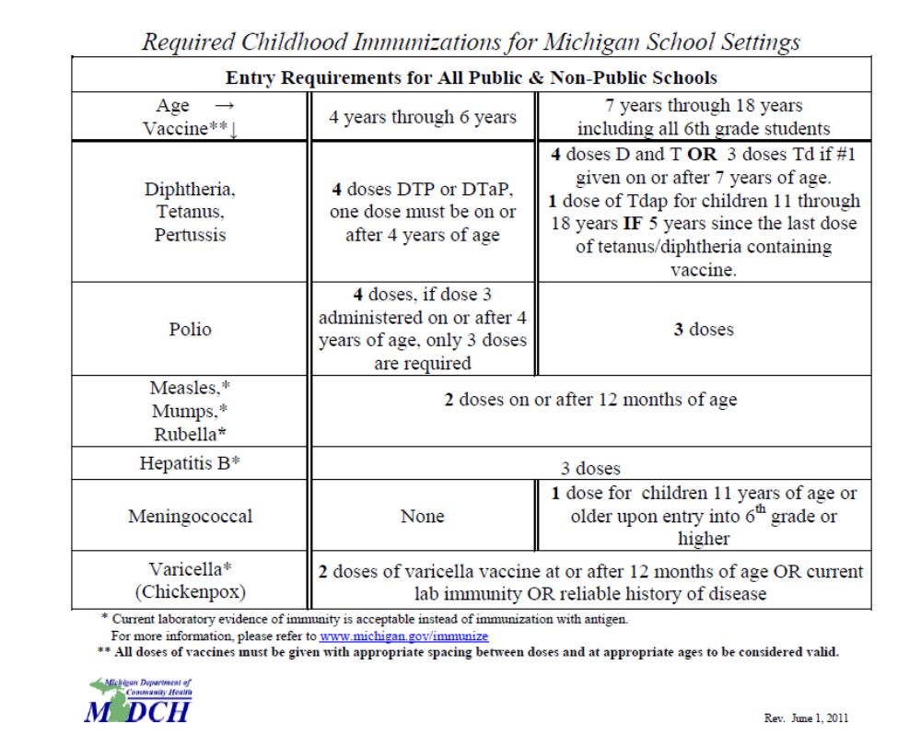

- Family Reunification Services
Your Case Manager will assist you with family reunification services and or resolution services when possible and appropriate.

Crisis Intervention
Guiding Harbor provides 24-hour crisis services if you are in need of non-medical emergency assistance or have a crisis that requires assistance from your Case Manager. Your Case Manager is available to you during regular business hours, which are Monday through Friday, 9:00 a.m. to 5:00 p.m. If you have a crisis after 5:00 p.m. or on the weekends, you may contact our On-Call worker who can assist you in solving your crisis. The following is a list of telephone numbers that will help you in a crisis:

During business hours – Monday through Friday – 9:00 am to 5:00 pm ---
- OFFICE: (734) 697-7242
After 5:00 pm & on weekends – call the On-Call Worker ----
- EMERGENCY ON-CALL CELL: (734) 634-3243

Portfolio
A portfolio is information that you will need when getting a job, a bank account, housing, etc. Your Case Manager will assist you in obtaining the necessary information for your portfolio. Prior to discharge you shall possess the following:

- Certified birth certificate
- School records
- Social Security Card
- Detailed Medical/Dental records
- State ID or Driver's License
- School Records
- Selective Service Registration
- Significant Contacts with Client and Significant Events
- ISP and most recent USP
- Court Documents
- Post- Assessment Documents
- Other material specified by DHHS

You will be provided a sign off sheet verifying that you received the above
information.

THE SIL/YAVFC CONTRACT -- WHAT IS IT & WHAT DOES IT MEAN?

Within the first thirty days of admission into the SIL/YAVFC program you will receive a contract for service. This mutually agreed upon contract is between you and Guiding Harbor. It will specify your responsibilities as well as the responsibilities of Guiding Harbor while you are in the SIL/YAVFC program. Your contract will outline your individual goals and will be updated every USP reporting period (90 days). If you are having any problems with fulfilling your contractual goals, your Case Manager will assist you. You will receive a signed copy of your contract.

REMEMBER: YOU & YOUR CASE MANAGER ARE “PARTNERS” IN YOUR MOVE TOWARD INDEPENDENCE.

WHAT DOES A CONTRACT INCLUDE?

Initial Contract
You and your Case Manager will devise your initial contract within the first 30 days of your placement. You will be expected to meet with your Case Manager to complete the following tasks:

- Complete your Initial Treatment Plan and set goals
- Familiarize yourself with daily program requirements.
- Enroll in an appropriate educational or vocational program.
- Open a bank account.
- Become familiar with local transportation i.e.: bus schedule and routes.
- Obtain a state ID.
- Complete your monthly budget.

On a monthly basis, you and your Case Manager will discuss & address your progress on your contract. Your contract will be reviewed and updated every USP period (90 days).

WHAT ARE MY RIGHTS?

RELIGIOUS EXPRESSION
You have the right to practice your religious faith as you see fit. Your Case Manager will assist you in locating churches, mosques, synagogues, etc. that are in the community in which you live.

MAIL
You have the right to send and receive mail. Mail expense is your responsibility.

DISCIPLINE
Guiding Harbor believes in natural consequences and practice positive reinforcement concerning discipline for rule infractions. Your Case Manager will continually strive to assist you in finding ways to understand the reasons and benefits of self-discipline and self-control.

Listed below are some behaviors that will not be tolerated in the SIL/YAVFC program. They are unacceptable in society and, therefore, are unacceptable while in the program. These behaviors can and will result in immediate removal from the program.

    - Stealing.
    - Assault, fighting and/or threats toward others.
    - Drug or Alcohol Use.
    - Property Destruction.
    - Gang Involvement.
    - Police Involvement.
    - Possession of weapons or contraband (i.e., guns, knives, explosives, drugs, drug paraphernalia, etc.).
    - Moving without your Case Manager’s prior approval and assessment of housing.

Guiding Harbor invokes a Zero Tolerance policy for these behaviors.

ADDITIONAL SIL/YAVFC SERVICES:

Michigan Works
All youth ages 14 and older will be referred to the local Michigan Works! Agencies (MWA) for participation in youth programs and services administered under the Workforce Investment Act (WIA).

Youth in Transition
YIT funds may be used to provide services that are not available from other funding sources or agencies for an eligible youth. All expenditures must support the youth in achieving self-sufficiency. This must be documented in the updated service plan (USP) or permanent ward services plan (PWSP). YIT funds may be used to provide the following goods and services after all other resources for the same good or service have
been exhausted.

Youth in Transition, (Michigan's name for Chafee ) is a funding source available to cover expenses NOT covered by other government or community resources, or to augment or supplement services from other funding sources.
  Eligibility Requirements
  - Michigan youth who are active in the foster care system, placed out of their home based on abuse and neglect, starting at age 14 and up to age 21.
  - Michigan youth, ages 18 to 21, that have been in foster care on or after their 14th birthday but are no longer under DHHS/Tribal supervision.
  - A youth who has or had an open juvenile justice case and is placed in an eligible placement under the supervision of DHHS.
  Where to Apply
  - A youth with an open case can access funds through his/her foster care case manager.
  - A youth with a closed case must apply for closed case services (YIT) in the current county of residence through the local DHHS office.
  - A tribal youth who was or is only supervised by a tribal court may contact DHHS at (517) 373-9219.
Covered YIT expenses include
  Daily Living Skills
  - Cooking.
  - Laundry.
  - Use of community resources.
  - Public transportation system.
  - Money management and budgeting.
  Transportation
  - Transportation for educational or employment purposes.
  - Bus or gas cards when needed for activity related to self-sufficiency.
  - Medical, including counseling transportation (closed case services only).
  - Driver's training.
  - Vehicle purchase if county allocation allows - $5,000.00 maximum limit.
  - Vehicle repair - not to exceed $900.00.
  Mentorship
  - Mentorships.
  - Family connection services if the youth is not covered by foster care family reunification services.
  Parenting Skills
  - Parenting skills/classes.
  - Day care costs not covered by FIP (but not denied due to noncompliance) for working teen parents and/or teen parents in educational/vocational programs.
  Employment Services
  - Career exploration.
  - Job training.
  - Job placement and retention.
  - Training in job-readiness skills such as interviewing, developing a resume, and job retention.
  - Job related supports.
    - Uniforms.
    - Tools.
    - Transportation.
    - Apprentice fees.
    - Safety clothing.
    - Equipment.
  - Interview clothing maximum of $250.00.
  Educational Support / Pre-college
  - Tutoring services.
  - Vocational placement.
  - Career planning.
  - College resources.
  - GED preparation and testing.
  - Educational testing and assessments.
  - Books and supplies for specialized classes.
  - Transportation.
  - Summer School.
  - School sponsored educational field trips.
  - College applications up to $150.00
  - SAT/ACT fees.
  - SAT/ACT preparation classes.
  * YIT funding can not be used for post secondary education expenses for students who are receiving ETV funding.
  Computer
  - Computer and accessories - maximum lifetime limit of $1500.00.
Graduation Expenses
Funding sources are available for graduation expenses
- Senior Class Ring.
- Tuxedo rentals and dress purchases for senior prom - up to $100.
- Senior cap and gown.
- Senior pictures.
- Announcements.
- Yearbook.

Physical and Mental Health Services
- Preventive health services - smoking avoidance, substance abuse prevention, nutrition, pregnancy prevention, personal hygiene, etc. if not covered by Medicaid or other health insurance.
- Individual or group counseling for the youth if he/she is receiving closed case services only.

Relationship Building Skills
- Classes or groups on interpersonal communication/relationship building and maintenance and Independent Living Skills.
- Coordination and connection between associated support people and the youth with various and appropriate community agencies and services.
- Membership in community organizations which would promote/support the youth with transitioning to independent living, i.e., YMCA/YWCA, Junior Achievement, Big Brothers/Big Sisters.

Housing
- Assistance in locating a suitable living arrangement.
- First month's rent, security deposits, and utility deposits for youth ages 18-21. There is a lifetime limit of $1,500.
- Start up goods lifetime limit of $1,000:
  - Personal hygiene.
  - Household cleaning supplies.
  - Basic household furniture.
  - Household utensils/tools.
  - Linens.
  - Household record keeping and accounting needs, etc.
  - Additional $500 in funds available for youth with children

FTM (Family Team Meetings):

Family Team Meetings (FTM) represents a family-centered, strength-based and team-guided decision making process designed to produce the optimal decisions concerning a child’s safety, placement and permanency. Family Team Meetings include child welfare staff, parents, caretaker(s), foster parents (of the children in Foster Care) and may also include extended family, friends, neighbors, community-based service providers, community representatives or other professionals involved with the family. The parents and child are encouraged to invite family, friends and/or other people they view as supportive or influential in their lives.

During the FTM, participants work together to create a plan for safety, placement and permanency tailored to the individual needs of each child. This process establishes a forum to share ideas and opinions, embraces the importance of the family’s perspective and involvement, stresses full participation of all attendees, encourages honest communication and promotes dignity and respect for all participants.

FTM’s are to occur as needed, at a minimum once per quarter. The FTM recommendation expires after 45 days, if another FTM has not occurred in its place. If a unanimous decision regarding the recommendation of the FTM cannot be made during the FTM, the decision is deferred to DHHS.

Certain circumstances or events and stages of a case progression mandate FTMs must occur within the required time frames as outlined below:

CHILD PROTECTIVE SERVICES:
Case Opening (ISP): Must occur within 30 calendar days before or 14 calendar days after case opening.

Open/Close: Prior to disposition.

Case Plan Reassessment (USP): Within 30 days before the case plan due date.

Court Intervention: Within seven business days of the date of the preliminary hearing.

Case Closure: Within 30 calendar days before case closure or one business day after unplanned court dismissal.

Request by Family: Within 14 calendar days of the request date.

FOSTER CARE:
Case Plan Development/Reassessment: Initial Case Plan (ISP); within 14 calendar days before the case plan due date.
Updated Case Plan (USP); within 30 calendar days before the case plan due date.
Permanent Ward Service Plan (PWSP); within 30 calendar days before the case plan due date.

Permanency Goal Review at Six Months in Care: Within 30 calendar days from the date the child has been in care six months.

Permanency Goal Change: Within 30 calendar days before the date of the goal change.

Placement Preservation/Disruption: At least three business days prior to a planned change of placement or no later than three business days after an unplanned placement change. Note: Planned and unplanned placement changes include reunification, placement in a residential setting, step-down from a residential or hospital setting, return from AWOLP, or request for change in foster home.

90 Day Discharge Planning Meeting: Youth age 16 or older must have a 90-Day Discharge Planning meeting within 90 calendar days before dismissal or within 30 calendar days after an unplanned court dismissal; Youth in Adult Voluntary Foster Care (YAVFC) must have a Discharge Planning Meeting within three business days of discovery that YAVFC eligibility requirements are not being met.

Semi-Annual Transition Meeting: Within 30 calendar days after the youth’s 16th birthday and every six months thereafter. For youth entering out-of-home placement at age 16 or older, the semi-annual transition meeting must be held within 30 days of the removal date.

CLIENT RIGHTS:
While receiving services at Guiding Harbor/Girlstown, you have the right to have appropriate care, supervision, food, clothing, shelter, services, safety and security. Many of these rights are required by law and Foster Care policy, depending on your age, developmental level and individual life situation. Guiding Harbor/Girlstown will ensure that your rights are communicated in a way that is understandable, available at all time, shared at the time of intake and annually thereafter.

Confidentiality
- The right of confidentiality of communication and of all personally identifying information within the limitations and requirements for disclosure of various funding and/or certifying sources, state or federal statutes, unless a release of information is specifically authorized by the client, parent or legal guardian of a minor client or court appointed guardian of the person of an adult client.

Access to Information
You have the right to:
- Access information pertinent to facilitate decision making.
- Have access to one’s own psychiatric, medical, or other treatment record, unless access to particular identified items of information is specifically restricted for that individual client for clear treatment reasons in the client’s treatment plan. “Clear treatment reasons” shall be understood to mean only severe emotional damage to the client such that of dangerous or self-injurious behavior is an imminent risk. The person restricting the information shall explain to the client, and other persons authorized by the client, the factual information about the individual client that necessitates the restriction. The restriction must be reviewed at least annually to retain the validity. Any person authorized by the client has unrestricted access to all information. Clients shall request to review their record in writing for viewing or obtaining copies of personal records.
- Be informed of one’s own condition, of proposed or current services, or treatment or therapies, and of the alternative.
- A current, written, individualized service plan that addresses one’s own mental health, physical health social and economic needs, and that specifies the provision of appropriate and adequate services, as available, either directly or by referral.
- Active and informed participation in the establishment, periodic review and reassessment of the service plan.
- Know the cost of services.
- Exercise any and all rights without reprisal in any form, including uncompromised access to service.

Legal
You have the right to:
- Access legal entities for appropriate representation.
- Have the opportunity to consult with independent treatment specialists or legal counsel at one’s own expense
- Understand all legal rights.
- Be provided with your attorney’s information.

Services
You have the right to:
- Consent to or refuse any service, treatment, or therapy on behalf or a minor client..
- Participate in any appropriate and available agency service (regardless of refusal of one or more other services, treatments, or therapies); unless there is a valid and specific necessity which precludes and/or requires the client’s participation in other services. This shall be explained to the client and written in the client’s current service plan.
- Be informed of and refuse any hazardous treatment procedures.
- Be advised of and refuse observation by techniques such as one-way vision mirrors, tape recorders, television, movies or photographs. Unless safety reasons are indicated.
- Be informed in advance of the reason(s) for discontinuance of service provisions and to be involved in the planning of the consequences of that event.
- Receive an explanation of the reason for denial of services.

Other Rights
You have the right to:
- Be treated with consideration and respect for personal dignity, autonomy, & privacy.
- Freedom from abuse, financial or other exploitation, retaliation, humiliation and neglect.
- Service in a humane setting, which is the least restrictive as defined in the treatment plan.
- Only receive medication that is medically necessary.
- Freedom from unnecessary restraint or seclusion; if restraint is an appropriate measure to keep the client safe, the client has the right to be restrained safely by a trained professional who takes into account the physical, developmental and abuse history of the client.
- Not to be discriminated against in the provision of service on the basis of religion, race, color, creed, sex, national origin, age, lifestyle, sexual orientation, gender identity, physical or mental handicap, developmental disability, pregnancy status or inability to pay.
- Be fully informed of all rights.
- File a grievance, to have oral and written instructions for filing a grievance and obtain resolution.
- Outgoing and incoming mail is not censored, unless there is a suspicion mail may contain unauthorized or illegal material. In that case, mail is opened by addressee in presence of designated personnel.
- Visit family, receive visits, and have phone calls with family members unless contraindicated by service plan.
- Have personal property and place for safe storage.
- Be free from exploitation in employment related or gainful employment
- Be provided with ethical treatment and research guidelines

GRIEVANCES & COMPLAINTS
Guiding Harbor encourages its clients to resolve any problem, concern, disagreement, complaint, and/or grievance through appropriate procedures. If you have a complaint in regards to services or your rights being violated, you may file a grievance. The Grievance procedure is as follows:

THE GRIEVANCE PROCEDURE
1. To begin the process, advise any staff person at Guiding Harbor that you wish to grieve about some problem with the agency’s treatment of you. This grievance may include, but is not limited to the following:
- DENIAL OF SERVICES
- INADEQUACY OF SERVICES
- PAYMENT OF FEES
- DISCRIMINATION IN THE PROVISION OF SERVICES
- ANY OTHER COMPLAINT REGARDING THE MANNER IN WHICH SERVICES ARE OFFERED OR DELIVERED
- Upon admission, each client will be provided with a copy of the attached Client Rights and Grievance Procedures. Upon request, anyone may receive a copy of this policy and procedure statement.
- In crisis or emergency situations the client will, at a minimum, be advised of their immediately pertinent rights.
- The Client Rights Statement and the Client Grievance Procedure will be posted in a prominent area where clients and visitors may review them.
- Upon the client’s written request, the Agency will forward information concerning the client’s grievance to any outside agent the client so identifies.
- Annually, the Clients Rights Advocate (COO) will arrange for training. Staff attendance will be mandatory.
- The Client’s Rights Policy will be posted in client areas and staff offices.
- A copy of both the Grievance Procedure and Client Right’s signoff, dated and signed will be kept in each client’s file to indicate receipt.
2. Your complaint must be in writing and include the date, time, description and/or names of individuals involved in the incident or situation being grieved. You may obtain assistance from the Client’s Rights Advocate in writing your complaint. You have a right to request assistance from a different advocate and Guiding Harbor will appoint someone to help you. The staff person that acts as a Clients Rights Advocate helps clients to exercise their rights, investigate grievances, and monitor agency’s implementation of the State administrative code regulations concerning client’s rights. The Client’s Rights advocate is responsible for explaining any grievance procedures.
3. Your complaint is then submitted to the Rights Advocate who will attempt to resolve the complaint and provide you with a written and oral explanation of the resolution within five (5) working days of your initiation of the complaint. If the Client’s Rights Advocate is providing direct services to you in another capacity, or you wish assistance from another advocate, Guiding Harbor will appoint someone else to assist you. The Client’s Rights Advocate will attempt to resolve your complaint. A complaint will not result in retaliation or barriers to service. Every effort will be made to resolve the complaint at this level, however if the incident is not resolved at this level you are encouraged to follow the next step.
4. If you are not satisfied with the decision, you may appeal to the agency’s Chief Executive Officer who will act as an impartial decision maker. The appeal must be initiated within five (5) working days after receiving the decision from the Rights Advocate. Within five (5) working days of receiving your appeal, the Chief Executive Officer will make a determination, in writing, regarding your complaint and schedule time to meet with you regarding your complaint. The Client’s Rights Advocate will be available to assist you in preparing your grievance and in its presentation if you desire to do so.
5. If the determination is not met to your satisfaction, then you may take your complaint to the Department of Health and Human Services (DHHS) or Community Mental Health (CMH) where applicable.
6. Guiding Harbor will assure that there will be resolution within 30 days of the initial grievance unless an extension is needed and will be done so in writing by the CEO.

CONFIDENTIALITY OF CLIENT RECORDS
The confidentiality of client records maintained by this program is protected by Federal law and regulations. Generally, the program may not inform a person outside the program that a client participates in the program or disclose any information identifying a client unless:
- The client or responsible adult consents in writing,
- The disclosure is allowed by court order, or
- The disclosure is made to medical personnel in a medical emergency or to qualified personnel for research, audit, or program evaluation.
Violation of the Federal Law and regulations by a program is a crime. Suspected violations may be reported to appropriate authorities in accordance with Federal regulations.
Federal law and regulations do not protect any information about a crime committed by a client either at the program or against any person who works for the program or about any threat to commit such a crime.
Federal laws and regulations do not protect any information about suspected child abuse or neglect from being reported to the appropriate authorities.

INDEPENDENT LIVING RECORD:
Guiding Harbor shall maintain a case record for each youth placed in independent living.
Guiding Harbor shall protect each record against destruction and damage and shall store and maintain each child’s record in a manner to assure confidentiality and to prevent unauthorized access. The case record shall contain all of the following information and documentation, which shall be recorded within 30 calendar days after placement in independent living and updated at least once every 90 calendar days:
All of the following personal information pertaining to the youth: name, social security number, address and telephone number, date of birth, gender, race, height, weight, hair color, eye color, identifying marks, A photograph updated on an annual basis, Documentation of the agency’s legal right to place a youth, The names, addresses, dates of birth, and social security numbers of the youth’s parents, if any, The names, dates of birth, and addresses of the youth’s siblings, if applicable, The names and addresses of any offspring, The names and addresses of any other significant persons, Current documentation of financial support sufficient to meet the youth’s housing, clothing, food, and miscellaneous expenses, The date, location, documented purpose, and a summary of the findings of each contact between the youth and the social service worker, Current adjustment, The youth’s relationship with family members and agency efforts to resolve family conflicts, Medical and dental records, Birth certificate, Change of placement documentation, Service plans as required, If the youth has biological children, the service plan must address the living arrangement for the child or children, visitation/parenting time with the youth’s biological children or a clear explanation why this is not possible or appropriate.

Guiding Harbor will maintain the record for not less than 7 years after the agency’s termination of services to the youth.

PROGRAM EXPECTATIONS

You must visit with your Case Manager at your regularly scheduled appointments or you may face being discharged from the program. It is mandatory that you visit with your Case Manager in your living situation at least once per month. It is paramount that your safety and well-being come first therefore the staff must know the whereabouts of your residence, employer and school at all times. Clients that miss a home visit are subject to a 30 day letter being sent to DHHS requesting their removal.

INDEPENDENT LIVING MODULES & MEETINGS

On a regular basis, your Case Manager will conduct a series of modules that will focus on practical skills that are necessary to live independently within the community. Your attendance is a required part of your SIL/YAVFC placement. Modules may also be arranged through guest speakers, community-based training or participation in inter-agency SIL/YAVFC collaborations. Modules are focused on daily living skills, household management, budgeting, money management, interpersonal communication, conflict resolution, employment, educational services, vocational training, substance abuse, effective use of medical, dental, & mental health services, preventive health services, community resource training and transportation.

Based on the Initial (30 day) and the USP (90 day) assessments individual trainings will be available for you in areas that have been defined as a need for you.

A training curriculum has been developed and the Supervised Independent Living Client Training Topics include but are not limited to the following: Alcohol, Drugs and Substance Abuse; Banking & Credit Issues; Careers & Long Range Plans; Communication & Interpersonal Relations; Community Resources, Including Transportation; Conflict Resolution; Contraception & Pregnancy; Domestic Violence & Date Rape; Educational/Vocational Options; First Aid & Home Safety Health & Hygiene; Household Maintenance & Upkeep; Legal Rights & Privileges; Locating & Maintaining Employment; Locating, Obtaining & Setting up a Residence; Male Responsibility; Money Management, Budgeting & Financial Responsibility; Prenatal/Postnatal Care & Parenting; Proper Use of Community Emergency Services; Rights of Renters & Landlords; Self-Esteem Development; Sex, Sexually Transmitted Diseases & AIDS; Shopping & Nutrition.

Methods to teach independent living skills shall include one or more of the following: lecture, discussion, question and answer, applied learning, role playing, guest speakers etc. The amount of time devoted to each topic is based solely on the individual needs of the client with the exception of guest speakers.

VISITORS

- WIN SITE PROGRAM – You may only have approved visitors while in the WIN SITE program. Your Case Manager will work with you and your mentoring adult in approving appropriate visitors and times that they may visit you.

- COMMUNITY LIVING PROGRAM - Because the COMMUNITY LIVING program affords you more independence, you will have to exercise your best judgment when it comes to visitors in your home. Take the opportunity to discuss with your Case Manager what is appropriate for you. Many young adults in this program may have problems with building appropriate peer relationships and as a result find themselves in difficult situations that may hinder their progress toward their personal goals. USE GOOD JUDGMENT – DISCUSS THIS WITH YOUR CASE MANAGER!!!!!!!

RUNAWAY/AWOLP (Absent without legal permission)

Youth who have difficulty dealing with conflict, anxiety, guilt or fear sometimes develop “defense mechanisms” of escape. These mechanisms may take many forms. They may appear as withdrawn, act out aggressively or truant from the foster home. One of the most difficult behaviors to deal with is runaway/truanting behavior. A youth can be considered to be on runaway status after his/her whereabouts are unknown at any time.

There are some steps to take which may reduce the potential for this behavior:
- If the youth has used this behavior in the past, avoid confrontation with the youth while he/she is experiencing stressful situations. Attempt, as much as possible, to reassure the youth of his/her safety and protection in the foster home.
- Observe the youth’s behavior just before runaway /truanting incidents and attempt to develop a set of “runaway signs”. These may include:
  - Aggressiveness
  - Evasiveness
  - Withdrawal (both physically and emotionally)
  - Increased anxiety or stress levels

The Case Manager may place a resident on AWOLP precautions. When this occurs, the following steps must be followed:
- The foster parent must be with the client at all times.
- The client is not permitted to take walks or unsupervised outings.
- The foster parent must thoroughly search the home and grounds for any packed bags or personal belongings. If found, confiscate.
- Monitor all activity in the house, especially the use of the telephone.

These will vary with each youth. As foster parents get to know the children that are placed in their home, predicting behavior will become easier.

If a child truants from school or the foster home the following steps must be taken IMMEDIATELY:
- Contact the local police department and file a missing persons report.
- Contact the Foster Care Case Manager or the On-Call staff immediately, relaying any information regarding the cause for the episode, possibilities of where the youth may be going and the clothing worn by the youth. Provide the Foster Care Case Manager or On-Call staff with the responding officer’s name, badge number, and the missing persons report’s log number.
- The Case Manager or On-Call staff has the responsibility of notifying the referring agency, parents/guardian, and child’s attorney.
- Submit an incident report within 24 hours

When the foster parent has filed an AWOLP report with the police the following information should be given:
- The youth’s full name
- Date of birth
- Physical description
- Clothing description
- Foster parents name, address and telephone number

If the youth is returned by the police or returns voluntarily, the foster parent should immediately notify the Foster Care Case Manager or the On-call staff. If the youth returns voluntarily the police should also be notified immediately.

When a child truants from a foster home the Foster Care Case Manager will inquire as to the foster parent’s intention to accept the child back into their home. A 30 day letter will need to be written to request removal of the child, unless the circumstances are too severe and do not warrant a return. If the foster parent is unwilling to take the child back payment will cease immediately.

AWOLP PROCEDURES (Absent without legal permission)

Foster Parents & Staff must be aware of each client’s whereabouts at all times. Client’s will be considered AWOLP for situations that include running away, skipping school, unapproved outings or being absent from the foster home. They must be reported as missing immediately when their whereabouts are unknown. Absent Without Legal Permission (AWOLP) is defined as a child who is placed with the Michigan Department of Health and Human Services (MDHHS) for care and supervision and who is absent from an approved placement without legal permission.

Immediately

Foster parent/relative caregivers, parents and residential facility staff must immediately notify law enforcement agencies (state police, local police or the sheriff’s department) and Guiding Harbor when a ward under their care fails to return at the expected time or leaves a home without permission.

Upon notification, Guiding Harbor staff (Case Manager’s) must immediately file a missing person report with the local law enforcement agency, classifying the youth as missing and endangered.

Upon notification, Guiding Harbor staff (Case Manager’s) must immediately notify the MDHHS monitoring worker of the child/youth's absence and within one business day must document the notification in the social work contacts in MiSACWIS.

Within 24 hours
Within 24 hours of the child’s absence, Guiding Harbor staff (Case Manager’s) must notify:

• The court of jurisdiction.
• The parents, if appropriate.
• Lawyer-guardian ad litem (LGAL).
• The National Center for Missing and Exploited Children (NCMEC) to inform the agency that the youth is missing and endangered. The phone number for the NCMEC's 24-hour call center is 1-800-THE-LOST (1-800-843-5678).

If a client is AWOL for more than 5 days, he/she will be discharged from the program. The DHHS worker has discretion to discharge a client immediately if they so desire.

When a client has gone missing from the program, the following steps must be followed immediately:

The Foster Parent or Residential Staff are required to:

- Search the home and grounds.
- Contact the local police department in their city and report her/him as AWOL from the program immediately.
- The foster parent/RTW will contact the Case Manager/RTW Supervisor or “On - Call” staff and inform them of the incident.
- If the AWOLP occurs during the weekend or not during business hours, the On-Call worker will contact the client’s Case Manager and leave a message. The On-Call worker is responsible to notify the DHHS Worker. This must be completed immediately. The Case Manager, RTW Supervisor will contact the DHHS Worker the following business day to discuss the AWOLP. If the AWOLP occurs during business hours the Case Manager will contact the DHHS Worker.
- Completely fill out an Incident Report form and include the report number from the local police department.
- Complete the local Police Department’s “Missing Person’s” report form.
- The foster parent/staff must pack all of the AWOLP client’s personal belongings, tag them with his/her name and secure their belongings.
- For residential clients the RTW on duty must make a copy of all three forms (Incident Report, AWOL Report Form & Missing Persons Form) and for Foster Care the Foster Parents must take the copies to local Police Department immediately. For SIL the Case Manager or On-Call Worker is responsible to take the forms to the Local Police Department. The originals must go into the Program Manager’s box for administrative review and distribution.
- Should the client return to the agency and report sexual activity with someone over the age of 16, foster parents/RTW staff/Case Manager should consider taking her/him to the nearest Emergency Room or institute the “Rape Kit” procedure in case of Criminal Sexual Conduct (CSC) charges that may need to be filed. It is the foster parent’s discretion to purchase RID shampoo for the client to shower and wash his/her hair with. Foster Parents/RTW Staff are to monitor the client and check her/his person.

Within One Business Day
Complete the DHS-3198A, Unauthorized Leave Report to Court/Law Enforcement.

The Case Manager is responsible for the following:

The Case Manager within 24 hours/1 business day of notification must:
- Update MISACWIS.
- Document action taken to locate the child in MISACWIS.
- Notify the DHHS monitoring worker of any additional information.
- Notify the MDHHS monitoring worker that a copy of the DHS-3198A, Unauthorized Leave Report, and a current photo of the child has been uploaded to MiSACWIS
- Send a copy of the DHS-3198A, Unauthorized Leave Report, to the court.
- Send/take a copy of the DHS-3198A, Unauthorized Leave Report, to the local law enforcement agency to ensure that the child is entered on the Law Enforcement Information Network (LEIN) as missing and endangered.
- Upload a copy of the DHS-3198A, Unauthorized Leave Report, and a current photo of the child to MiSACWIS.
- Complete the DHS-710, Clearance to Publish Children AWOLP on DHS Web, obtain required signatures, and forward to the Child Locator Centralized Unit; see Criteria to Place a Child/Youth on the Child Locator Website, in this item.
- Document the report to the NCMEC, as an AWOLP contact in the social work contacts in MiSACWIS
- If local law enforcement refuses to place child on LEIN, the caseworker must document in MiSACWIS and forward information to the Child Locator Centralized Unit.
- Document all contacts in MiSACWIS.
- Forward copy of the DHHS-3198A to the court.
- Forward a copy of the DHHS-3198A and the child’s current photo to the DHHS monitoring worker.
- The Case Manager must notify the Court of jurisdiction within 24 hours and the L-GAL within 24 hours.
- The Case Manager will notify the parents, guardian or caregiver within 24 hours.
- The Case Manager will assure that a copy of the DHHS-3198 A is sent to the court. They will assure that a copy of the DHHS-3198A to the local law enforcement to ensure that the child/youth is entered on the Law Enforcement Information Network (LEIN) as MISSING and ENDANGERED. They must also retain a copy in the case file. The Case Manager must confirm that child has been entered on LEIN and document in case file. If local law enforcement refuses to place child on LEIN, the worker must document in case record and forward information to the Child Locator Centralized Unit.

DILIGENT SEARCH
Within Two Business Days
Guiding Harbor will conduct a diligent search for the child as soon as possible but within the first 48 hours and document efforts in the case contacts. The Case Manager is responsible for the following:
- Review all available information in the case file/MiSACWIS records to identify information on the potential location of child, for example, family members, unrelated caregivers, friends, known associates, churches, and/or a neighborhood center.
- Contact the school that the child last attended. Verify that the child is not in attendance and determine if there are friends/teachers of the child who may have information.
- Contact the local school district office(s) to determine if child has enrolled in a new school.
- Complete an internet search and/or search social networking sites; for the child, the child's parents, known relatives and/or acquaintances, if applicable.
- Document results of all contacts in MiSACWIS.
- Forward any new results of contacts to the court and law enforcement.
- Caseworkers may use the DHS-991, Diligent Search Checklist, as a guide for the search. If the DHS-991, Diligent Search Checklist, is used, the caseworker must upload the completed form to MiSACWIS.

*Note if this occurs during the weekend or not regular business hours the On-call worker is responsible to follow the steps above.

Ongoing AWOLP Diligent Search
At a minimum Guiding Harbor will conduct a diligent search for the child every calendar month and repeat a diligent search each month until the child is located. The Case Manager must document all efforts to locate a child and any child initiated contacts into the USP/PWSP and Court Reports. The Case Manager must continue to notify law enforcement of any further new information to aid in their efforts to locate the youth.

An Action Summary will be completed within 5 days of AWOL which will include a narrative termination summary and reason for termination. If a client remains AWOL for more than 30 days the belongings will be stored and secured at the agency. When a child is AWOL for more than 90 days the belongings will be given to the DHHS worker.

WHEN AN AWOLP YOUTH IS LOCATED
As soon as possible, but no later than one business day after locating the youth, Guiding Harbor will take the following actions:
- Notify the NCMEC that the child has been located.
- Notify local enforcement that the child has been located.
- Notify her/his parents, the DHHS worker. L-GAL, the Court and “On - Call” worker.
- Complete an AWOL Return Report form, which can be documented on an Incident Report form.
- Complete an Incident Report regarding the return from AWOL
- Place originals of all reports in the Program Manager’s box.
- If the client appears to be injured, seek appropriate medical attention.
- Conduct a (Placement Preservation/Disruption) Family Team Meeting within three business days of the youth’s return to care.
- As soon as possible, but no later than five business days after locating the youth the Case Manager must meet with the youth to determine the following:
    - The primary factors that contributed to the youth running away.
    - The ways in which the youth's placement should respond to those factors.
- The youth's activities while AWOLP, including if the youth was a victim of sex trafficking.

Return from AWOLP Conversation Guide
Case Managers may utilize the DHS-5333, Conversation Guide on Return from AWOLP, during the discussion with the youth.
If it is suspected that the youth was a victim of human trafficking, the Case Manager must immediately contact Centralized Intake at 1-855-444-3911, for a complete investigation.
Documentation
This conversation must be documented in the social work contacts in MiSACWIS, with the purpose categorized as Interview w/youth on Return from AWOLP. Specific details of the conversation should be documented in the Additional Narrative section of the social work contact by the Case Manager.

OTHER:

If the resident is a PA-150, the Office of Juvenile Justice Director must be notified within 24 hours. The telephone number is (517) 335-3489 and the FAX number is (517) 241-2663. The following information is needed at the time of the call:
  - Date and time of AWOLP
  - Name of client
  - Age of client
  - County of Commitment
  - Name of Agency and program
  - Committing offense
  - Any other significant information surrounding the AWOLP

Client’s will be considered AWOLP for situations that include running away, or being absent from their home environment.

If a client is AWOLP for more than 5 days, he/she will be discharged from the program. The DHHS Worker has discretion to discharge a client immediately, if they so desire.

OUTINGS & CURFEWS

- WIN SITE PROGRAM – Because the WIN SITE program is designed for your continued supervision, it is important that you work with your Case Manager and mentoring adult in planning outings and meeting curfews. For your own safety you must adhere to reasonable, safe rules and guidelines, you must also leave written notification of where you will be at all times, this can be done on a monthly schedule. If an emergency arises you must leave a message with your Case Manager explaining your change of plans. Unexplained absences will be considered AWOL and reported as such to your DHHS Worker and police. If you plan on taking an overnight trip you must inform your Case Manager at least five (5) working days in advance. This is so your Case Manager can receive written approval from your DHHS worker.

- COMMUNITY LIVING - Your time outside of your work, school and program time requirement is your own. For your own safety, however, you must adhere to reasonable, safe rules and guidelines, you must also leave written notification of where you will be at all times, this can be done on a monthly schedule. If an emergency arises you must leave a message with your Case Manager explaining your change of plans. Unexplained absences will be considered AWOL and reported as such to your DHHS Worker and police. If you plan on taking an overnight trip you must inform your Case Manager at least five (5) working days in advance. This is so your Case Manager can receive written approval from your DHHS worker.

SCHOOL & WORK ABSENCE
If you are going to be absent from school or work for more than 2 days, call your Case Manager by 9:30 a.m., and give the reason you are absent.

A. If you are ill, give an accurate description of your illness. You will then need to go to the doctor and provide a complete medical visit form.
B. If you are going to legitimately be absent from school, your Case Manager will call the school and have the absence excused. If you are going to be absent from work, you must call your employer.
C. You are to call each and every day you are absent.
D. When you return to school, contact each teacher so that you are aware of what you should be studying and what homework assignments were missed.
E. If you become ill during school or work, please follow the special guidelines of your school or place of employment to have your absence excused during the day and contact your Case Manager.

HOW DO I PAY MY BILLS?
You will receive a stipend of $297.78 every two weeks while you are in the SIL/YAVFC program. Your stipend totals $638.10 monthly. Your stipend will be used to pay your bills and teach you the essentials of money management. Your stipend will not cover all of your bills therefore your plan for employment is essential to assist in building a financial foundation. You and your home provider agree upon your payment for room and board depending upon your level of care. Most home

HOW DO I KNOW WHEN I AM READY TO BE DISCHARGED?
In order to be considered for discharge to Independence, clients are required to:

- Have been employed on a consistent basis for 6 months.
- Have successfully completed the Treatment Plan.
- Have obtained a financial base in savings.
- Secure sufficient furnishings for next phase in living plan.
- Displayed competency in compliance with program rules and expectations.
- Score higher than your initial score on the Daniel Memorial.

THE ROLE OF STAFF MEMBERS

Staff members are employed by the agency to ensure that you have a safe and appropriate experience while at Guiding Harbor. Staff members of the agency are always to behave in a manner that is consistent with this role. The following is a list of things that staff should not do:

Staff should never:

- Provide you with their home address, home or cell phone numbers.
- Invite you to their home.
- Request that you engage in a falsehood or lie with them or for them.
- Tell you about their personal life and family.
- Spend time with you when they are not on shift or working.
- Have you visiting their homes or their churches.
- Introduce you to family members or friends of theirs.
- Talk to you about agency decisions that you have no control over.
- Talk negatively to you about other staff members or clients.
- Borrow or give you clothes, cigarettes, contraband or money.
- See, E-mail, write or phone you after they know longer work for Guiding Harbor.
- Ask you to keep or share a secret with them.
- Use inappropriate language in your presence.
- Ask you to pay for any service of the agency.
- Threaten to harm you physically.
- Be inappropriate with you in any manner.
- Have a stake in the housing that you reside in.
GUIDING HARBOR
SUPERVISED INDEPENDENT LIVING
CLIENT AGREEMENT WITH SIL SITE HOME PROVIDER

SIL SITE Home Provider agrees to provide a friendly environment in which the client can live within their community, develop, learn and grow to become a capable, responsible and caring adult.

This agreement is made this ________ day of _______, 20____ between Guiding Harbor and the SIL SITE Home Provider regarding the client's residence at:

Provider’s Name:
Address:
City / State / Zip:
Telephone:
Email: ____________________________________________________

By signing this agreement the signers agree to adhere to the following SIL policies and procedures:

1. Room and Board:
Client will be provided a room. Payment to the Home Provider $______ for rent (not to exceed $275) and $_____ for washer and dryer use, to be paid on a bi-monthly basis. Utilities (Electric and Gas) are to be included in the rent portion of your monthly stipend.

2. Phone:
It is necessary that all SIL clients maintain a telephone for emergency purposes. If there is misuse of the telephone it is the SIL's client’s responsibility to pay the telephone bill. The client shall maintain a phone card for long distance calls if that is what is agreed upon between them and their home provider.

3. Problem Solving:
Day to day problems arise in all living arrangements. The client is expected to work with their Case Manager and the Home Provider to solve any problems that may arise. If the client violates the agreement or if a serious problem arises, the Case Manager is to be contacted to determine the process of problem resolution. Generally, the Case Manager will administer any consequences for contract violation or other behavior problems. House rules and contract are established with input from all parties concerned. Any variation in this plan will be mutually determined.

4. Transportation:
The client is responsible for finding her/his own way of getting from one place to another. Guiding Harbor staff is not to be depended upon for transportation. The SIL client is not to use any vehicle without a driver’s license or automobile insurance. (It is illegal to instruct anyone to drive who does not have a valid Michigan Operator's driving permit.) Guiding Harbor is not to be held responsible or liable for motor vehicle accidents.

5. Family Contact:
The client can make contact with biological parents if approved in their treatment plan. Visits must be coordinated between the client and the Case Manager.

6. Appointments:
Attendance by client to any programs/meetings scheduled by your Case Manager is absolutely mandatory. Cooperation between the Case Manager and Client is a must. All appointment times and plans of action will be adhered to. Client must be in school, a training program or working towards G.E.D.

7. Personal Planning:
Client must be willing to discuss, create and maintain a schedule of time and a personal budget. Other areas of planning to be discussed include clothing, savings account, cosmetics, toiletries, cleaning/laundry, entertainment and curfew. Guiding Harbor will supervise the client including the following: dental, medical, school, employment, contact with parent or guardian, clothing, entertainment, and volunteerism, weekend visits away from home and finances. Client is encouraged to become involved in a personal enrichment activity, which could include any one of the following: organized sports, joining a club or organization, attending church or participating in a hobby.

8. Religious Expression:
Each client will also be supported in learning about the availability within the community or various means of religious expression. Your Case Manager will encourage the exposure of religious, spiritual, and philosophical beliefs to young people in our program. Religious preference and decision to worship shall be up to the individual client.

9. Mail:
All clients within the SIL program are permitted and encouraged to send and receive mail at their expense.

10. Grievances:
Guiding Harbor and the Supervised Independent Living program encourage Home Providers and clients, to take steps to resolve any problem, concern, disagreement, complaint, and/or grievance in relation to the program. These matters should first be discussed with the Case Manager. If the event that matter is not resolved within three (3) working days, the grievant may contact the Program Manager. If, again, the complaint cannot be resolved, the grievant may contact the Chief Operating Officer. All grievances and complaints must be presented in writing.

11. Emergencies:
In case of an emergency, illness, or accident the Case Manager must be notified first and then the Program Manager or Chief Operating Officer of Guiding Harbor must be notified immediately. The client is responsible for maintaining a Medicaid card in his/her possession at all times. If the call is after business hours, it must be reported to the on-call worker by phone at (734) 634-3243.

12. Termination:
Illegal behavior is a reason to be terminated from the Program. This includes the use of illegal substances, alcohol, gang involvement, destruction of private property (i.e.: holes in walls, cigarette burns, water damage, etc.) Moving without permission from the agency will result in immediate termination. All home providers agree to provide the agency with a 30 day notice prior to requesting removal of a child unless the child is a danger to himself or others and must be either hospitalized or removed by the police.

- Resident Handbook:
Clients, family members and guests shall comply with all rules and regulations in the resident’s handbook. Clients must obey all laws and ordinances applicable to the premises and to engage in no activities in or on the premises of an illegal nature, purpose or intent. Clients and their guests shall never be disorderly or unlawful and shall not disturb the rights, comforts and conveniences of their Home Provider.

- Default:
In the event that a client fails to make rental payment, within the agreed upon time period, Guiding Harbor should be notified immediately. It remains the client’s responsibility to make rental payments. Guiding Harbor will not make rental payments for any youth in their care nor will they pay for damages of any kind.

SPECIFIC CLIENT RESPONSIBILITIES
- I will be involved in an educational program and or be employed for at least 30 hours per week.
- I will pay my rent on time and be responsible to cover all costs related to maintaining my residence in this home.
- I will not take part in any illegal behavior, including the use of alcohol or drugs.
- I will keep my room / living space clean and orderly.
- I will conduct myself in a pleasant manner.
- I will follow the special instructions of the Case Manager when necessary.
- I will adhere to any rules that the Case Manager and I have deemed necessary.
- I will abide by all program guidelines and the resident handbook.
- I will maintain weekly contact with my Case Manager& schedule 1 home visit per month with my Case Manager in my home environment.
- I will abide by the rules and regulations of Guiding Harbor and the Home Provider and I will follow the SIL handbook and the client agreement with my SIL SITE Home Provider.
- I will have my home assessed prior to moving.
- I must be employed full-time, actively involved in job training or continuing education, or a combination of employment and education and provide documentation of such.

HOME PROVIDER RESPONSIBILITIES:
- I will provide the agency with a 30 day letter for a client’s removal unless the client is going to be hospitalized or removed by the police.
- I will provide the client with their possessions at discharge from my house.
- In the event of non-payment of rent I will inform the Case Manager, but I am aware that Guiding Harbor cannot make any payments for the client and will not make rental payment or pay for damages.
- I have the right to take the client to small claims court in the event that there is property damage or they fail to comply with this rental agreement.

COMMENTS (any additional areas or expectations not covered in this agreement, be specific):

AGREED by Client ___________________________________Date________________
AGREED by Home Provider ___________________________Date________________
Case Manager______________________________________ Date______________
Program Manager___________________________________ Date________________
Date Mailed to client/Home Provider: _____________________________
*This contract is to be updated annually REVISED MEL 4.15

GUIDING HARBOR

SIL/YAVFC CLIENT CONTRACT (90 DAY)

NAME: ____________________________ DHHS CASE #:_________________

Location where the client is residing:______________________________________

_____________________________________________________________________

CONTRACT PERIOD: FROM____________________TO:____________________

Provided to client on:_______________________ How provided:_______________

As a client in the Guiding Harbor SIL/YAVFC Program, I will be receiving independent living benefits supported through the Department of Health and Human Services. In order to remain a client in the SIL/YAVFC program and continue to receive these benefits, I agree to all of the following conditions:

REQUIRED RESPONSIBILITIES:

- I will meet with my SIL/YAVFC Case Manager at a minimum of once per month in my residence, I realize if I fail to do so I may be terminated immediately from the program.

- I will assume responsibility for all of my actions under Guiding Harbor rules as outlined in my SIL/YAVFC Handbook and abide by laws of the city, state and county where I live.

- I will remain in my current placement until I am successfully discharged from the program. I will inform my Case Manager at least 30 days in advance of any moves that I may anticipate and will not move without permission of my Case Manager.

- I will maintain full or part time employment in conjunction with my educational program at least 30 hours per week.

- I must be employed full-time, actively involved in job training or continuing education, or a combination of employment and education and provide documentation of such. My plan for education and/or work is:
A)

B)

C)

D)

E)

- I will meet the following special conditions and goals for employment and my education program as agreed upon with my Case Manager: (these conditions will address hours of employment, work habits, special training assignments, and other pertinent factors):

A)

B)

C)

D)

E)

- I will follow my Treatment Plan as agreed upon with my Case Manager. If I am unable to meet the expectations of my Treatment Plan, I will notify my Case Manager before hand and ask for whatever help is needed for me to achieve each goal.

- I will attend all mandatory SIL/YAVFC program meetings and classes.

- I will be responsible for scheduling and keeping my own medical and dental appointments.

- I will be responsible for arranging my own means of transportation. I will not depend on Guiding Harbor staff to transport me to my appointments or to any other activity that I plan.

- In case of an emergency or accident, I will notify the on-call worker at Guiding Harbor immediately. The On-Call telephone number is (734) 634-3243.

- I will not allow any alcoholic beverages, illicit drugs, or weapons of any kind to be used or brought into my residence by anyone (including myself) at any time.

- I will have weekly telephone contact with my Case Manager.

- I will have a minimum of 1 monthly home visit with my Case Manager in my home/residence.

RESPONSIBILITIES WITH MY CASE MANAGER:

I will meet with my Case Manager monthly and do the following:

- Provide accessible hours for home visits and meet with my CM a minimum of once per month in my residence.

- Provide a monthly schedule that will reflect class times, work times, and planned events such as grocery shopping and approved home visits.

- Provide copies of all medical and dental appointments including my yearly health appraisal and dental visits.

- Provide a copy of my bank statements and monthly pay stubs, as often as I receive them and the name of a contact person at my place of employment.

- Provide a copy of my grades and the name of a contact person in my educational program.

- Provide a copy of my budget and be financially responsible for any and all debts that I incur.

- Attend regularly scheduled classes and trainings.

- Provide a budget to my Case Manager monthly.

- Attend therapy when assessed as a need.

- Accept referrals and at minimum schedule referred appointments within 30 days or less.

CASE MANAGERRESPONSIBILITIES:

The Guiding Harbor Case Manager agrees to the following:

- Will arrange for an independent living stipend to be received every two weeks.

- Will provide employment counseling and support services for you and

arrange for on the job assistance and services with you and your employer if problems arise.

- Will meet with you monthly at minimum in your home/residence to review the requirements of your BUDGET, SIL/YAVFC/YAVFC CONTRACT & TREATMENT PLAN.

- Will review your budget and offer assistance with financial planning.
- Will have weekly telephone contact with you.
- Will assess your needs and strengths and provide you with referrals for areas that you have deficits/needs in.

- Will conduct a series of classes that will focus on practical skills that are necessary to live independently within the community.

- Will teach independent living skills that include one or more of the following: lecture, discussion, question and answer, applied learning, role playing, peer group meetings, guest speakers etc. The amount of time devoted to each topic is based solely on the individual needs of the client with the exception of guest speakers.

- Will assist you with many treatment issues and based upon your needs she/he will make referrals for continued therapeutic treatment (group or individual counseling) to a therapist or counselor with a minimum or a Master’s degree who is certified or licensed by the State to provide said services.

- Will advocate for you related to employment while assisting you in locating, obtaining and maintaining employment. Your Case Manager will have contact with you and your employer at least once per month to monitor your performance and progress.

- Will meet with you at your monthly scheduled home visits to complete and discuss your budget and how you manage your stipend.

- Will assist you with family reunification services and or resolution services when possible and appropriate.

- Will assess functional levels in reading and math upon intake, unless this has been assessed in the last 12 months. Establish an educational plan that is updated at regular intervals and coordinate with appropriate educational institutions to monitor progress, or receive written progress reports from the educational institution at least monthly.

Violations or problems with this agreement will be discussed with your Case Manager. This contract will be reviewed and renewed every three months for SIL/YAVFC Clients and every six months for YAVFC Clients or as needed during my stay at Guiding Harbor. I understand that the rules and responsibilities as outlined in this Contract cannot change unless all parties meet to discuss the changes. I further understand that if I do not meet the above conditions, my independent living/YAVFC status may change and my stipend may be terminated immediately. My signature below acknowledges my receipt of this contract.

____________________________________ _______________
Client Date

____________________________________ _______________
Case Manager Date

____________________________________
Telephone

____________________________________ _______________
Program Manager Date
Revised: MEL 4.15
Guiding Harbor
SIL/YAVFC/YAVFC Training Documentation Form

I _______________________________________________________
have been provided with training in the following area(s):
__________________________________________________________
__________________________________________________________
__________________________________________________________
__________________________________________________________

Training Hours: _________________________

______________________________ _____________
Client Name Date

______________________________ _____________
Staff/Trainer Name/Credentials Date

REV: TM 6/20/2013
Guiding Harbor SIL/YAVFC Budget Worksheet
_______________________________ (Client Name)
Month of __/__/__ to __/__/__

INCOME this Month EXPENSES this Month
iNCOME sOURCE | aMOUNT
Stipend | $ +
Employment | $ +
Other Income  (Odd Jobs/Soc.Sec.) | $ =
Total Income | $ (A)

Rent | $ +
Cell Phone | $ +
Clothing | $ +
Food | $ +
Entertainment | $ +
Other | $ =
Total Expenses | $ (B)

TOTAL SAVED THIS MONTH | $ (c)
TOTAL in SAVINGS  (before this month) | $ +
TOTAL IN CHECKING | $ +
TOTAL OTHER SAVINGS | $ =
TOTAL SAVINGS before WITHDRAWALS | $
TOTAL  WITHDRAWALS from SAVINGS  (subtract) | - $
GRAND TOTAL  SAVINGS | $
TOTAL SAVED this MONTH TOTAL SAVINGS
iNCOME THIS MONTH | $ (A)
TOTAL  EXPENSES THIS MONTH | - $ (B)
Total Saved this  Month | = $ (C)

Client Name/Date

Case ManagerName/Date

Program ManagerName/Date
Revised 6/20/2013
GUIDING HARBOR
SIL HOME VISIT/COMMUNITY CONTACT

Client Name: Date:
Time of Contact: From To
Visit location (address)
Did contact occur in the client’s home? Yes ◻ No ◻
Who else participated in the visit?
Purpose of Contact:
Monthly Home Visit ☑ Other: Explain:
SIL Budget Completed: Yes ◻ No ◻
Treatment Plan Discussed: Yes ◻ No ◻
Due dates: Physical: Dental: Vision:
Contract:
Content of Contact:
Living Situation:
Date of Home assessment:
Assessment of living situation: (living conditions,)

Education (enrollment status, performance, attendance, educational recommendations etc.):

Last contact with the school; with whom?
Employment
Paystubs provided? Yes ◻ No ◻

Medical (diagnosis, concerns, medication, doses, treatment, appointments, follow up care)

Mental Health: (Diagnosis, name of therapist, date, time, issues, treatment goals, follow up services)

Social: (how are needs being met, participation in any activities)

Emotional: (how are needs being met)

Behavior/Behavior Management: (behavioral issues, type of disciplined used)

Referrals:
YIT Yes ◻ No ◻ NA ◻ Date:

What was requested?
Michigan Works Yes ◻ No ◻ NA ◻ Date:
MRS Yes ◻ No ◻ NA ◻ Date:
Section8/Housing Yes ◻ No ◻ NA ◻ Date:
Was a FTM held this quarter? Yes ◻ No ◻
If so what type of FTM and what was the outcome?

Any additional IL skills/Referrals that were made:
Receipts/documentation provided:
Bank statement provided? Yes ◻ No ◻ (please attach)
How much money is in: checking savings
Is there any information from the last visit that is still a concern?

Top Priorities for this visit
- _______________________________________________________________________
- _______________________________________________________________________
- _______________________________________________________________________

Up coming events:
◻ Dental/Physical ◻ Therapy ◻ 90 Day Contract ◻ Annual Trans Meeting

◻ FTM MEETING ◻ Action Summary/PCN ◻ Court

Follow up activities Person responsible Target Date

Client Signature: Date:

Case Manager Signature: Date:

Program Manager Signature: Date:
**attach a copy of all received documents to this form REV: MEL 12.13
GUIDING HARBOR SIL PRE-INTAKE NOTES

Client Name:__________________Date of Assessment: ___________________
Eligibility Requirements: Age:_____________ School enrolled in:_____________
Job status (where employed/length of employment/full or part time)___________
________________________________________________________________
The basis for concluding that a youth exhibits self-care potential & SIL is the most appropriate placement for the youth as evidenced by:______________________________________________________________

It is determined that _____________________________ exhibits self-care potential per:

____________________________ has been observed in __________________

It has been determined by (Case Manager)_______________________ that this situation is safe and it has been determined that the youth has a bed and access to cooking and bathing facilities.

The availability of specific and relevant resources to meet the specific needs of the client including:
- Social _____________________________________________________
- Physical ____________________________________________________
- Educational _________________________________________________
- Vocational __________________________________________________
- Emotional __________________________________________________

Evaluation of the client’s need for supervision is (remain with home provider, reside on their own, live in dorm)______________________________________

Plan to provide supervision if necessary________________________________
________________________________________________________________

* A bi- monthly stipend is provided to each youth in the SIL program of $18.27 per day (this is to meet housing, clothing, food and misc. expenses). A contract is completed post-intake with the home provider that indicates the youth’s expenses (see home provider/client contract) (see budget sheet for financial support)
_________________________________ ____________
Case Manager Date
_________________________________ ____________
Program Manager Date
*Note- This must be completed prior to intake REV:MEL: 4/1/15
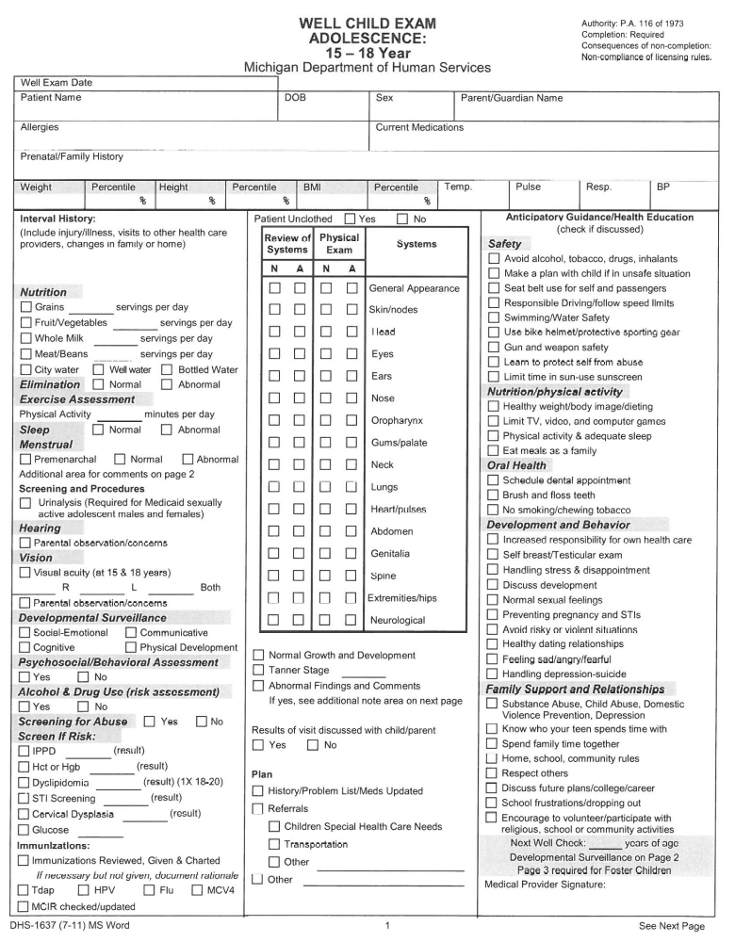
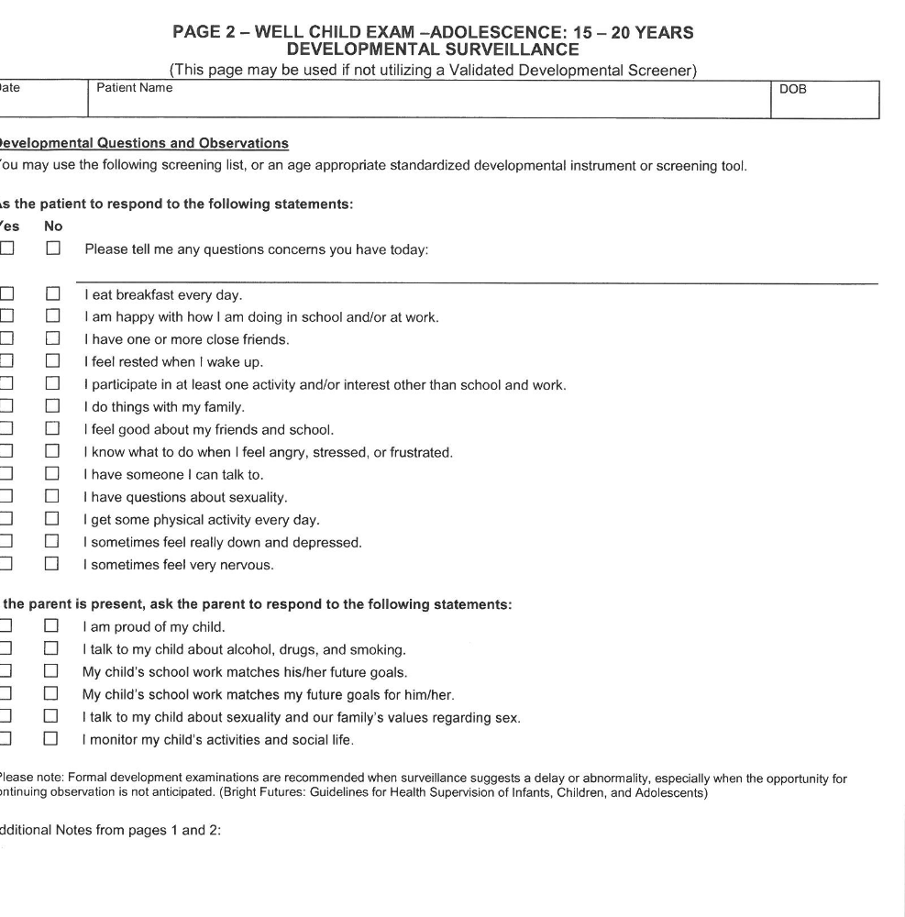
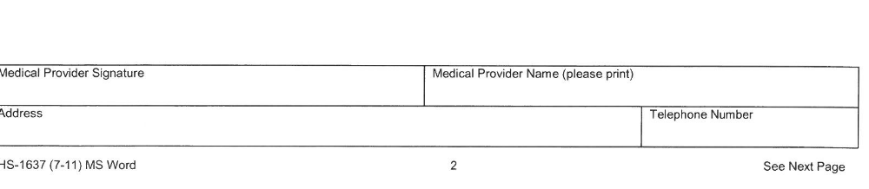
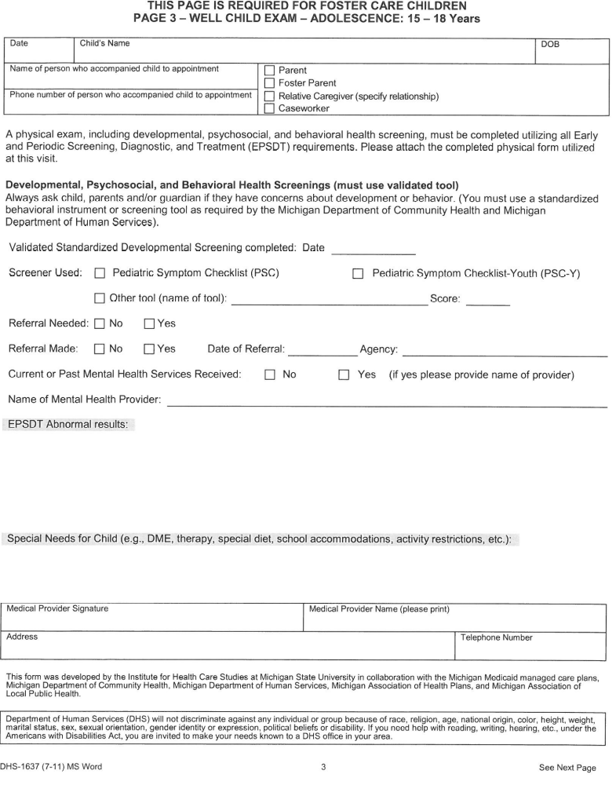

GUIDING HARBOR
MEDICAL VISIT REPORT

Client Name:_______________________________ Date:___________________
DOB:_____________________________________

TO BE COMPLETED BY Guiding Harbor Staff/Foster Parent//SIL/YAVFC/YAVFC CLIENT:
Physician’s Name/Specialty:_______________________________________________
Date/Time of Appointment:________________________________________________
Complaint/Ailment:______________________________________________________
______________________________________________________________________
Allergies:______________________________________________________________
Current Medications:_____________________________________________________
Documentation received: □ Yes □ No (If documentation was received attach)

TO BE COMPLETED BY DOCTOR’S OFFICE:
Diagnosis:______________________________________________________________
Doctor’s Recommendations for treatment and follow up: _________________________
_______________________________________________________________________
_______________________________________________________________________
Referral needed: □ Yes □ No If so what type:__________________________________
Additional follow-up appointment necessary: □ Yes □ No
If so what type:__________________________________________________________

________________________________ _____________________________
Guiding Harbor Staff Signature Date Physician’s Signature Date

REV: TM 6/20/2013

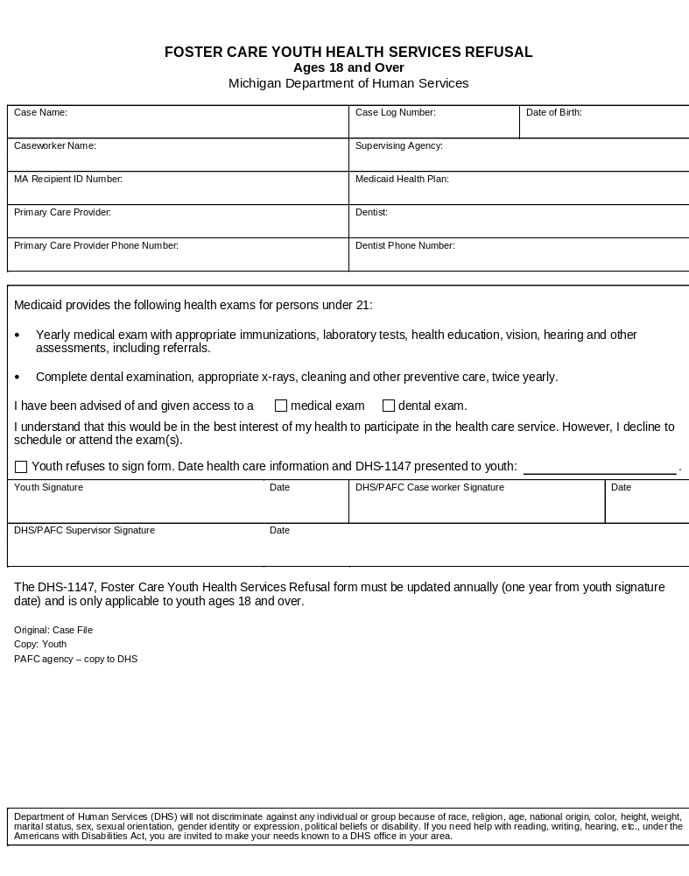

Guiding Harbor
Supervised Independent Living

Employment Log

Client Name:

Name of Employer:

Employer Address:

Employer Phone Number:

Supervisor/Manager Name:

Position:

Start Date:

Full or Part Time:

Does Client Consent to Contacting Employer: Yes No
Guiding Harbor
Supervised Independent Living

Educational Advisor Contact

Client Name:

Does Client have an advisor assigned to them? Yes No

Name of College/University:

Advisor Name:

Advisor Phone Number:

Advisor Email Address:

Does Client Consent to Contacting Advisor: Yes No

GUIDING HARBOR

CLIENT EXIT QUESTIONNAIRE

YOUTH NAME: ______________________________DATE: __________

PROGRAM: □ Girlstown □ Foster Care □ SIL/YAVFC

- Why were you referred to Guiding Harbor for services?

- List the 3 most important goals staff helped you to establish:

- What goals were the “hardest” to accomplish? Why?

- Was the staff helpful by listening to your problems, helping you, etc.?

- How was the program Handbook helpful?

- List 3 of the changes you have made since completing the program:

- What will you continue to need help with?

- How can we improve this program and what areas need improvement?

- Were you able to access all services needed for your treatment?

- Were you able to access services efficiently/timely?

- Were the services that you received effective (did they meet your needs)?

- Additional comments, recommendations or suggestions:

PLEASE SEND DIRECTLY TO THE ATTENTION OF THE CONTINUOUS QUALITY IMPROVEMENT CHAIRPERSON – Kristen Plezia, Chief Operating Officer.
Revised: 7/28/14

GUIDING HARBOR
CONTINUOUS QUALITY IMPROVEMENT SURVEY
General Information:
□ Client □ Parent □ Referral Source_______________County

Program:
□ Girlstown □ Foster Care □ SIL/YAVFC

Were there additional services not offered that you required? □ No □ Yes
If you answered Yes please list those services:______________________________
___________________________________________________________________

What improvements, if any would you recommend?

In the program:______________________________________________________

In the services provided:_______________________________________________

Were services offered in a timely manner? □ Yes □ No
Did staff keep you informed of progress/problems, etc …? □ Yes □ No
Did the services provided meet your needs? □ Yes □ No

Please rate the level of satisfaction in the following areas:
Very Satisfied Satisfied Dissatisfied Very Dissatisfied
Intake Process
Referral Process
Quality of Services
Discharge/Transition Planning
Clinical Staff
Residential Staff
Case Management
Manager/Supervisory Staff
Quality of Facility/Program
Cultural Competency of Staff
Additional Comments, Recommendations or Suggestions (use back if necessary):
________________________________________________________________________________________________________________________________________________________________________________________________________________________________________________________________________________________________ ML: REV 7/28/2014


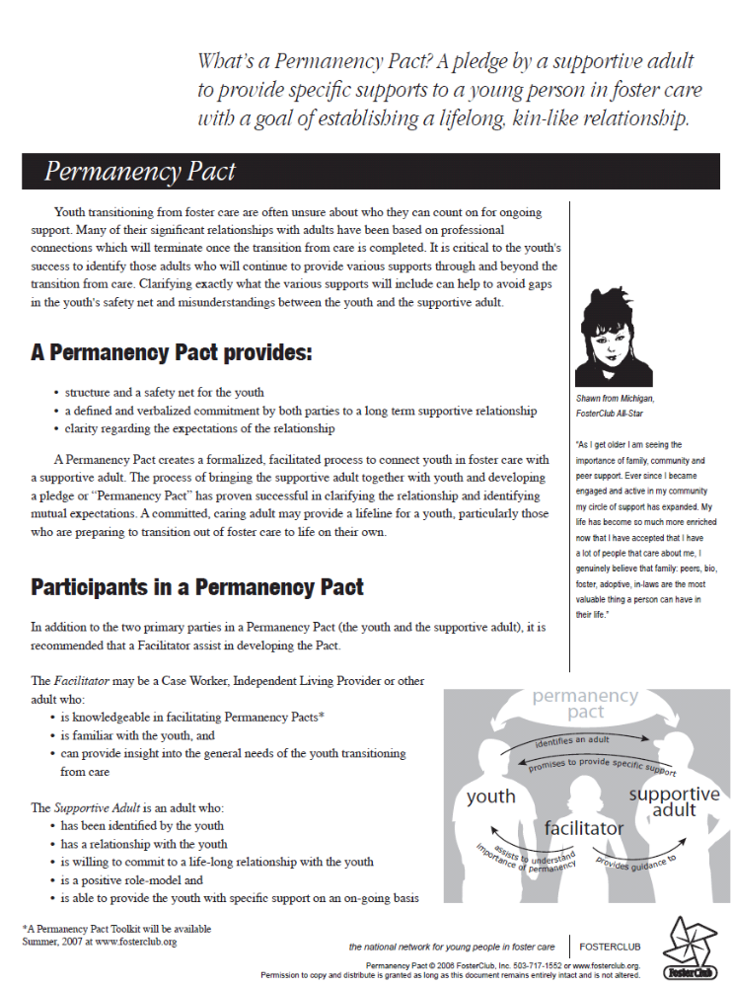

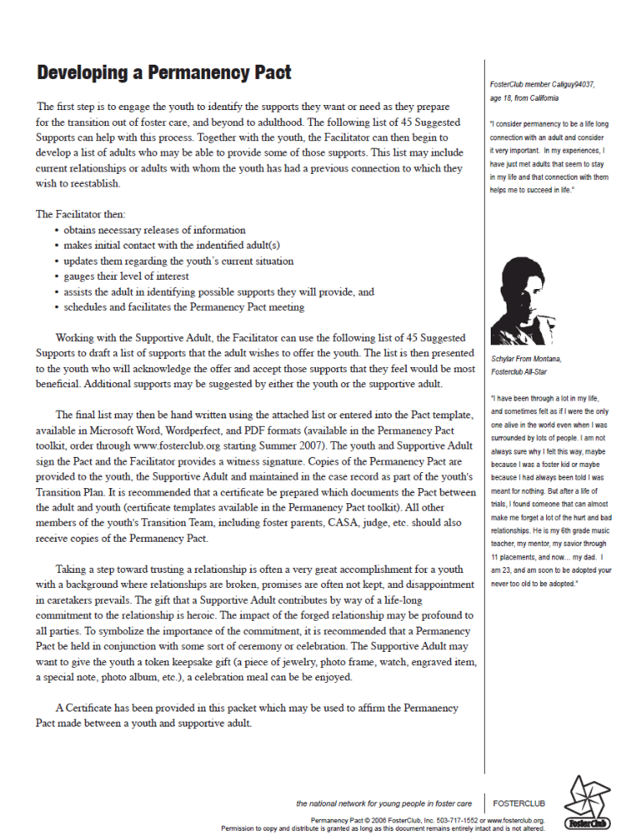
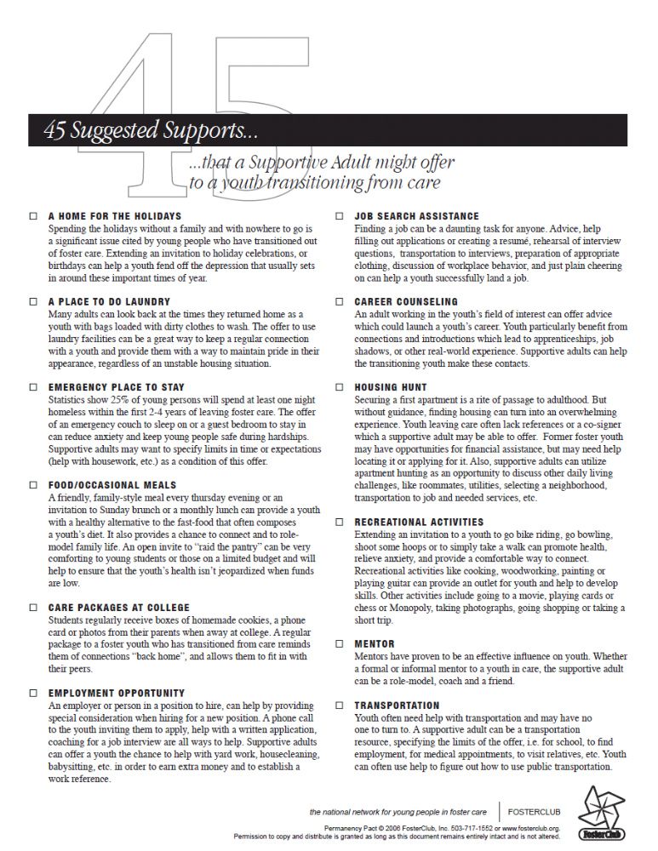
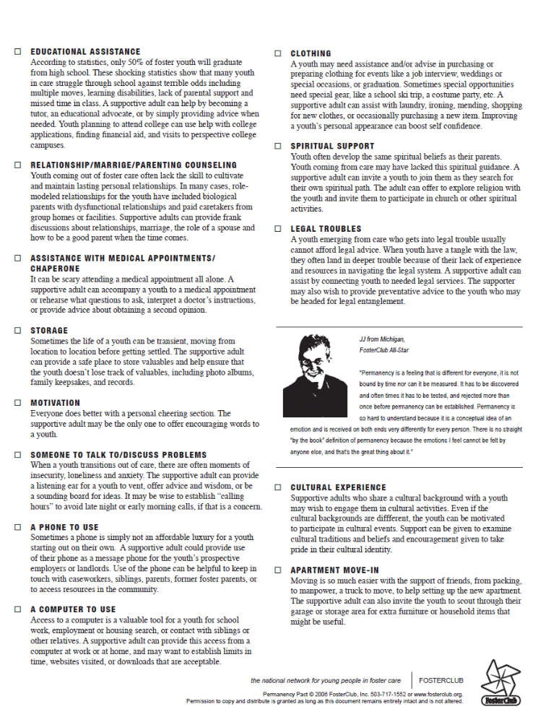
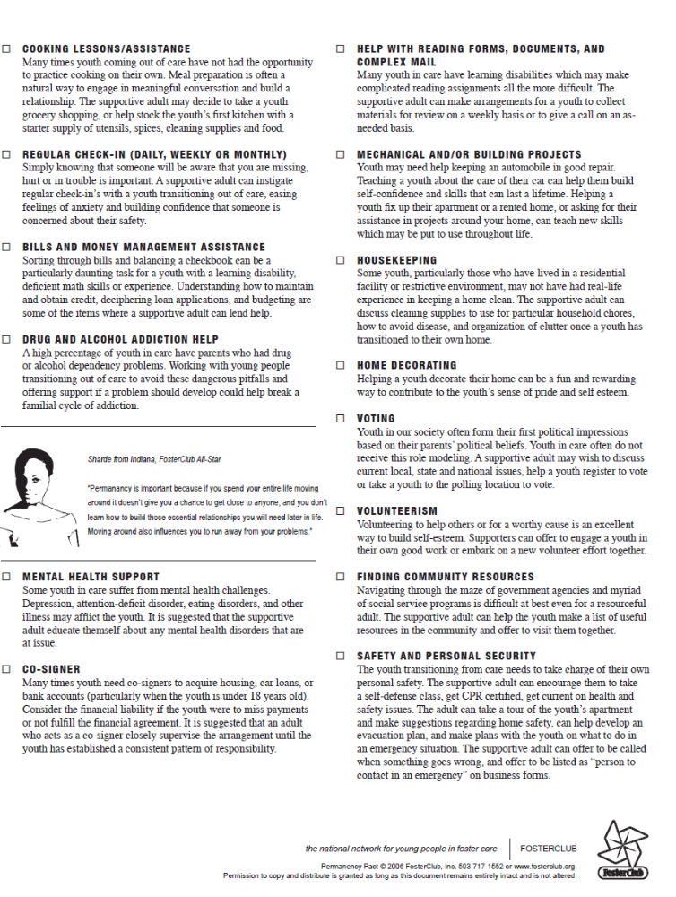
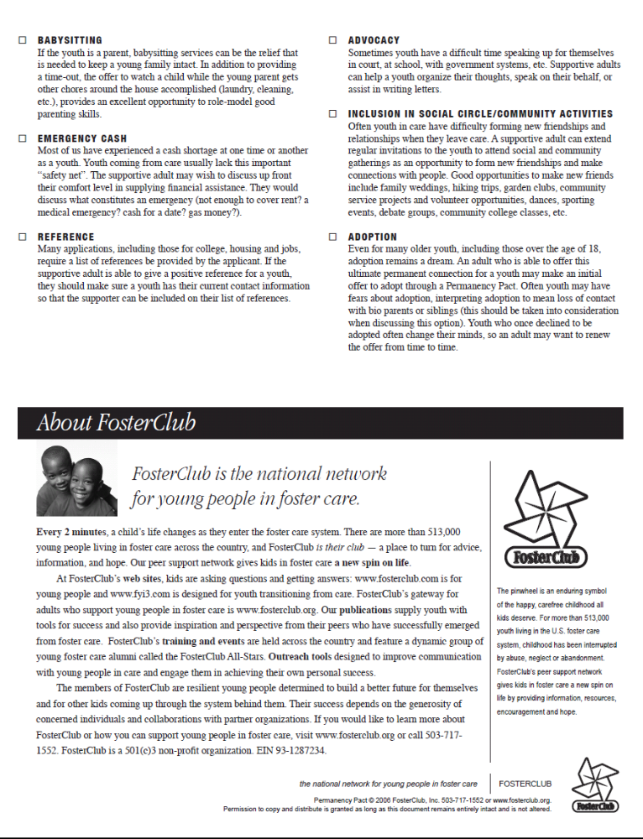
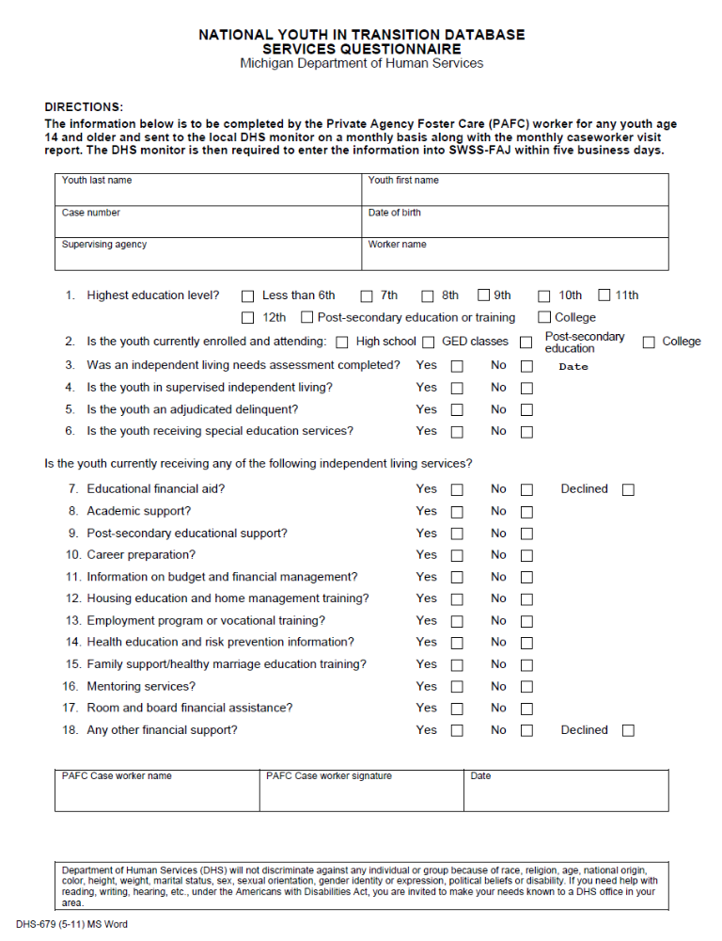

Emergency Telephone Numbers:

During business hours (Monday-Friday, 9:00 am - 5:00 pm)
- OFFICE: (734) 697-7242
After 5:00 pm & on weekends – call the On-Call Worker
- EMERGENCY ON-CALL CELL: (734) 634-3243

Case Manager/Name:

Telephone Number:

Guiding Harbor SIL/YAVFC and YAVFC Discharge Information

I ______________________________________________

Agree that I have received the following information upon discharge from the Guiding

Harbor Supervised Independent Living and the Young Adult Voluntary Foster Care programs:

- Certified birth certificate
- Social Security Card
- Detailed Medical/Dental records
- State ID or Driver's License
- School Records
- Selective Service Registration
- Significant Contacts with Client and Significant Events
- ISP and most recent USP
- Court Documents
- Post- Assessment Documents
- Other material specified by DHHS
- Information about healthcare services, housing, counseling services, and emergency resources

I also agree that Guiding Harbor has released any funds or personal property to me

upon discharge.

My current address is: _____________________

______________________

______________________

________________________________ _______________________
Client Date

________________________________ _______________________
Case Manager Date

REV: TM 6/20/2013
RECEIPT OF SIL & YAVFC HANDBOOK

I ____________________________________________________ have received a copy

of the Supervised Independent Living and the Young Adult Voluntary Foster Care

Handbook for 2017. I have read and reviewed the Handbook and agree to adhere to the

rules and regulations put into place by Guiding Harbor. If I have a grievance I will follow

the procedures to file a grievance. I will adhere to my contract and agree to complete a

new contract with my Case Manager at least every 90 days. I will provide my Case

Manager with school progress reports quarterly and a copy of my paycheck monthly. I

will also complete a contract with my home provider at least once per year. I also agree

to keep my Case Manager apprised of my living situation and will not move without

prior consent.

____________________________________________ __________________
Client Date

____________________________________________ __________________
Case Manager Date

REV: ML 2017

Population Served | Male and female children (ages 16-21) of any race, color, religion, height, weight, pregnancy status (to be evaluated based upon safety of the fetus and client), sexuality or national origin.
Settings | Clients are placed in homes with providers or in independent housing. In addition, they must have completed high school and/or, at admission, be enrolled in an academic/ vocational program. The youth must be job ready or currently employed.
Hour/days of Service | 7 days per week, 24 hours per day
Frequency of Services | The Supervised Independent Living and (YAVFC) Programs provides services include at minimum monthly SIL/YAVFC training, monthly case management services including case coordination and advocacy, employment assistance & financial planning, educational & vocational planning, health & dental care and assistance as needed and at minimal annually, crisis intervention as needed, monthly stipend and money management assistance,
Payer Sources | All payments are made by DHHS through MISACWIS
Fees | $28/day administrative, $21.27/room and board (paid to the client)
Referral Sources | Michigan DHHS
Services Offered | Case Management services which include but are not limited to ongoing supervision, case coordination, referrals and support, community based referrals for mental health services, educational planning and services, family visitation, family team meetings and case conferences, pre-placement assessment and visitation when permissible, court responsibility (for SIL), home visits and telephone contact, independent living skills assistance, employment assistance, staff support including a 24 hour emergency on-call

